|  |  |
| --- | --- |
| **Celebrate:**  **How do we act as Christians?** | |
| Celebrate God’s beautiful world. |  |
| The words and actions of the Sign of the Cross. |  |
| We enter God’s family, the Church, through Baptism. |  |

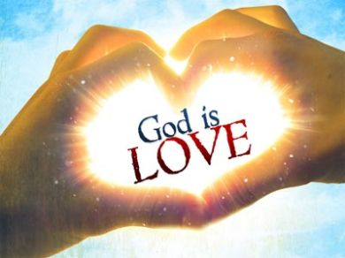

|  |  |
| --- | --- |
| **Hear:**  **What Scripture will we Hear?** | |
| The words and actions of the Sign of the Cross |  |
| God created the world and said “Indeed it is very good.” (Genesis 1:31) |  |
| The whole of creation shows God’s love for us. |  |

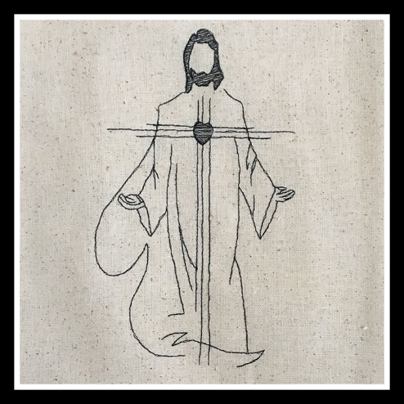

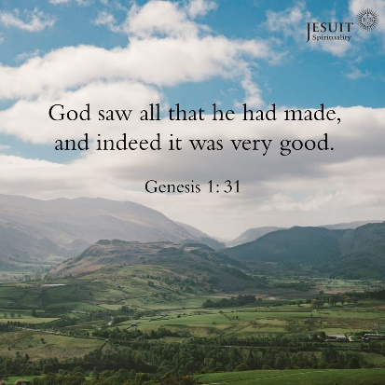

|  |  |
| --- | --- |
| **Believe:**  **What do Christians Believe?** | |
| God is love. |  |
| God made each of us. |  |
| God loves each one of us as a unique person. |  |
| God made a wonderful world and what God creates is good. |  |
| God loves us and we are part of a family. |  |
| God tells us we must take care of the world – it is an important job. |  |

|  |  |
| --- | --- |
| **Live:**  **How do Catholics live out their Faith?** | |
| Care and love for self, family, others and God’s world. |  |
| God made each of us, so each one of us is very special. |  |
| We must treat others in a caring way because God made them too. |  |

**Key Vocabulary**

Father Son Holy Spirit

wonderful love

family world