|  |  |
| --- | --- |
| **Celebrate:**  **How do we act as Christians?** | |
| Pray the Hail Mary prayer |  |
| Hear and sing the first phrase of the Gloria, recognising it as the angels song of praise to God . |  |
| Hear and sing traditional carols. |  |

God loves us

Mary is our mother.

The story of Jesus’ birth.

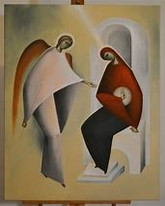

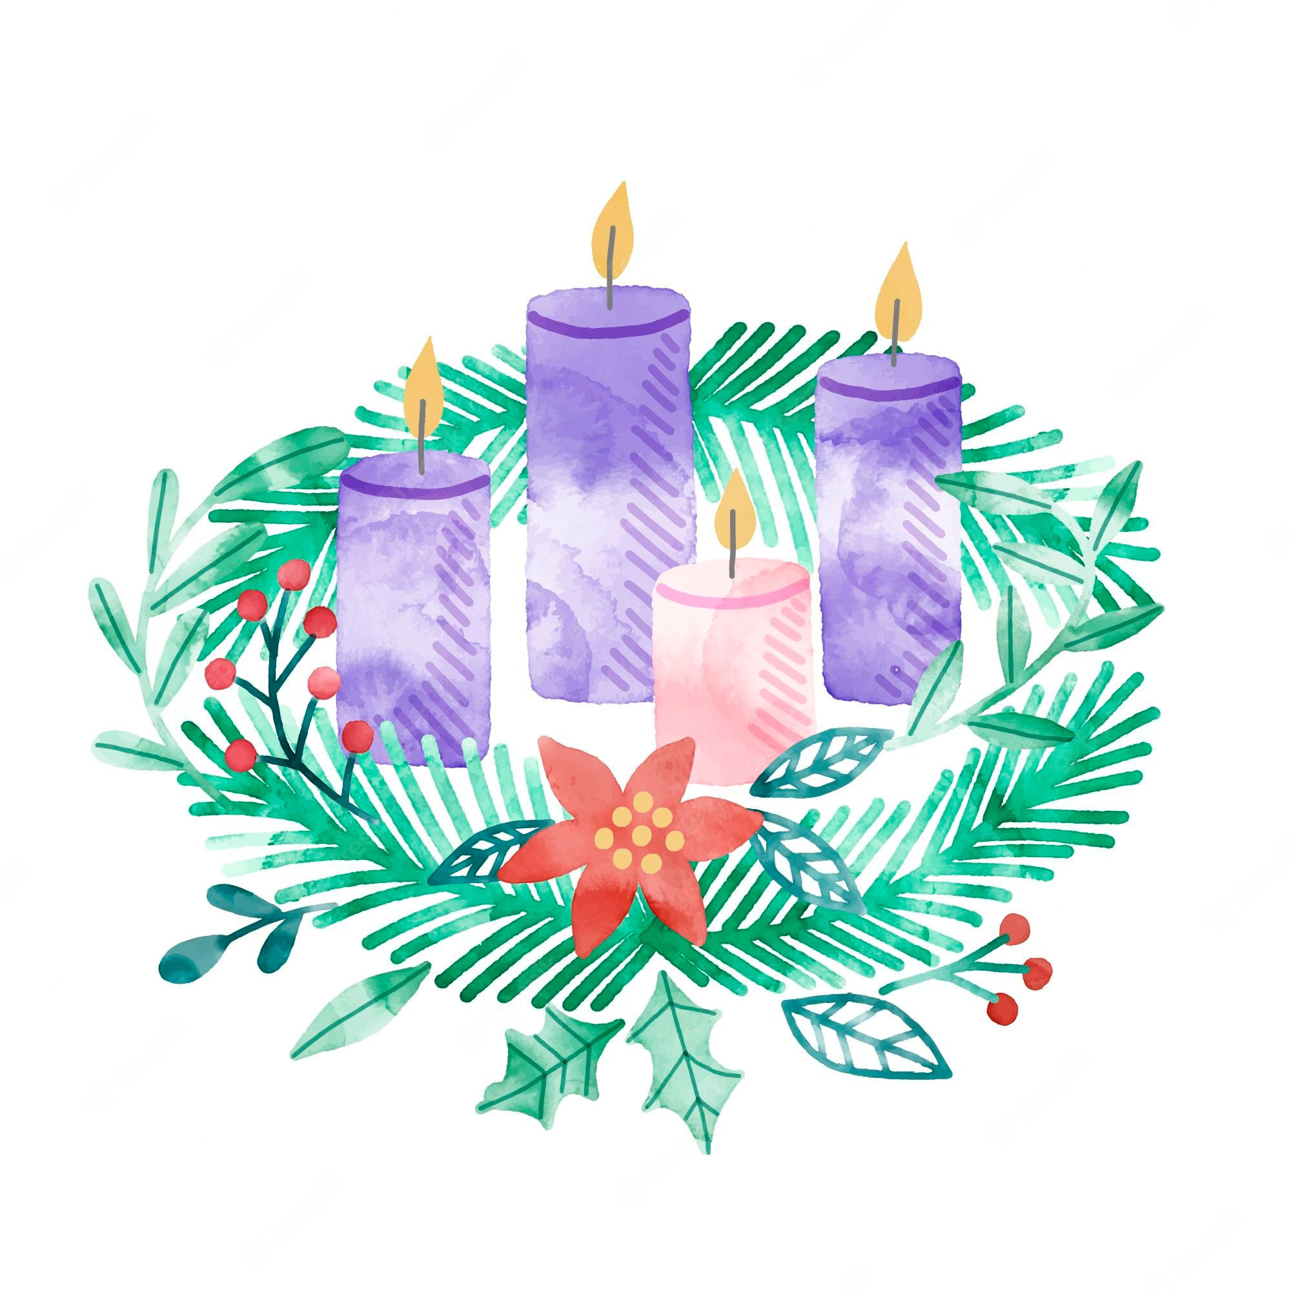

|  |  |
| --- | --- |
| **Hear:**  **What Scripture will we Hear?** | |
| The Annunciation (Lk 1: 26-38, focusing on 1:26-32, 38) |  |
| The Visitation (Lk 1:39-45) |  |
| The Birth of Jesus (Lk 2:4-8) |  |
| The Visit of the Shepherds (Lk 2:8-20) |  |

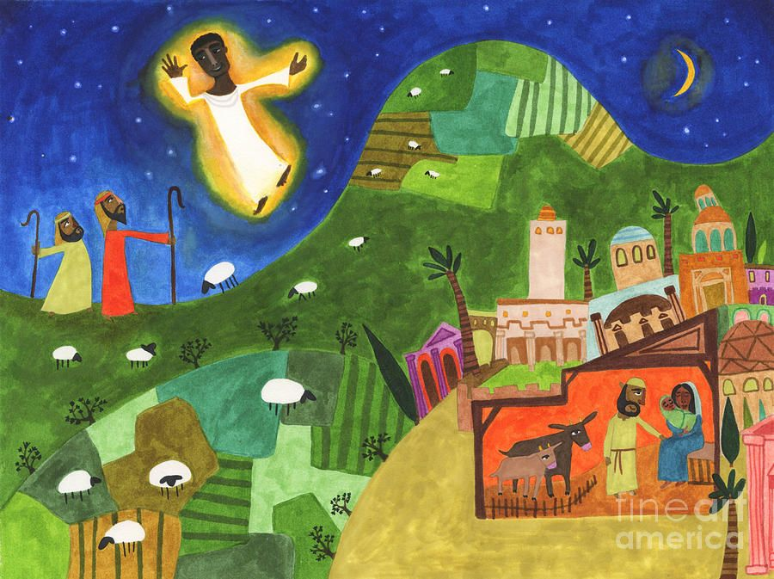

|  |  |
| --- | --- |
| **Believe:**  **What do Christians Believe?** | |
| Because God loves us he gave us his only Son Jesus. |  |
| God called Mary to be the mother of his Son, Jesus. |  |
| Mary said ‘Yes’ to God. |  |
| Angels bring God’s message. |  |
| The stories about Jesus are in a special book called the Bible. |  |

|  |  |
| --- | --- |
| **Live:**  **How do Catholics live out their Faith?** | |
| Through the art, songs, and sculptures of Mary. |  |
| Christians in their local community celebrate the birth of Jesus. |  |
| Christians go to church.  Act out the Nativity.  Light the Advent Wreath candles |  |

**Key Vocabulary**

Mary Joseph Jesus Bethlehem waiting visitation Annunciation Christmas Advent Birthday