**My school and my local area – knowledge organiser**

**What can you see?**

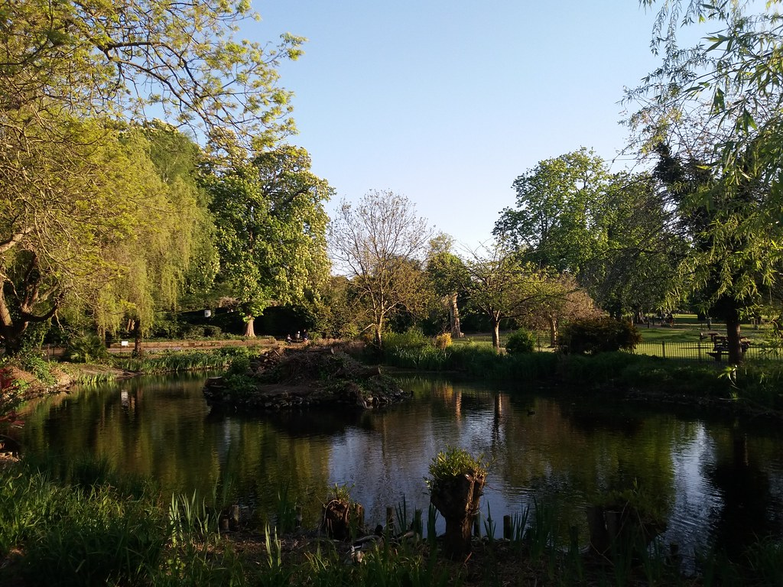

Pond/lake/river

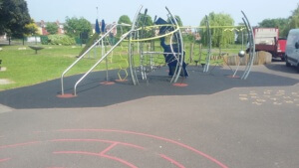

Play equipment

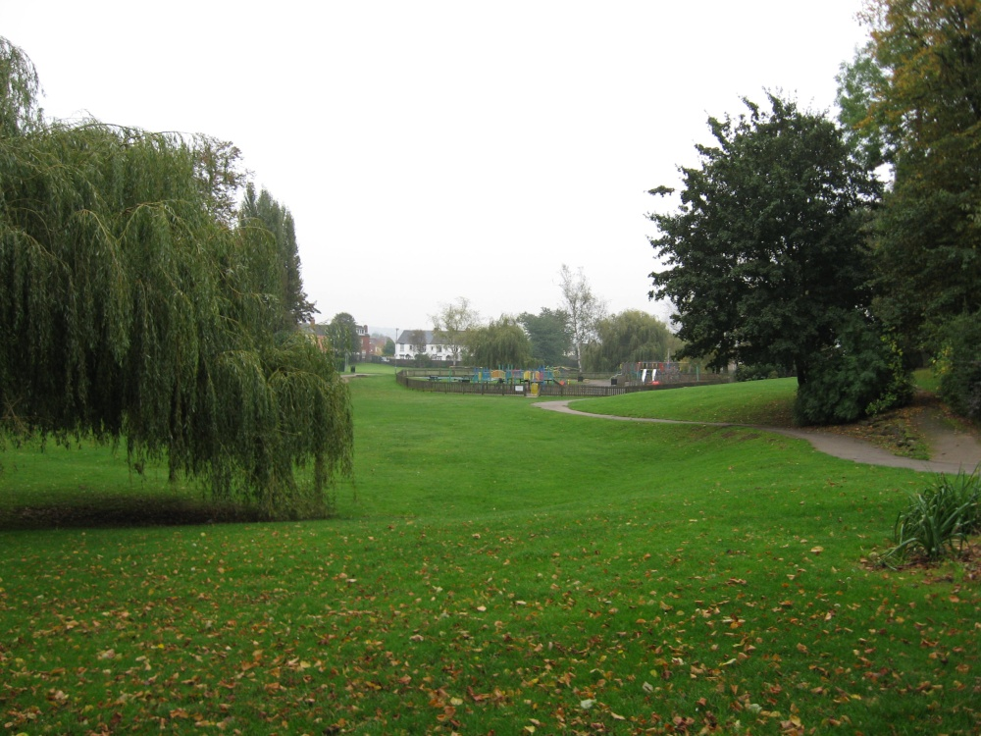

Green spaces

**Key vocabulary**

**Local area** - where you live.

**Map** – a drawing of an area shown from above

**Ariel view / birds eye view** – what something would look like from above, looking down.

**Fieldwork** – working outside to collect information.

**Route** – how to get somewhere.

**Address** – a place where someone lives

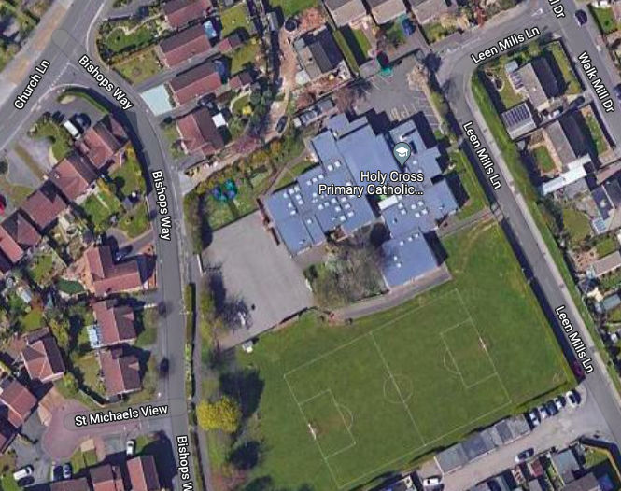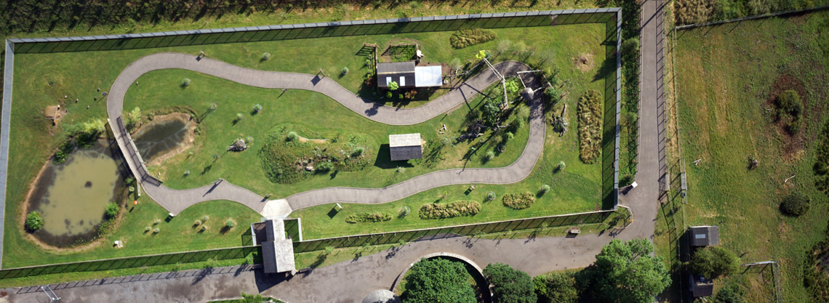

Ariel Photograph



**Maps**

• Sometimes have a key with symbols

• Show the distance between places

• Can use colour

Ariel Photograph