Reception Homework - Due back Monday 25th November 2024

As part of our RE topic, the children have been thinking about the countdown to Jesus’ birthday.

During Advent we mark the countdown to Christmas with an Advent wreath.

For homework make an advent wreath to bring in and share with the class. This can be made from natural materials or can be a craft wreath. Talk to your child about the significance of the different candles and what they represent.

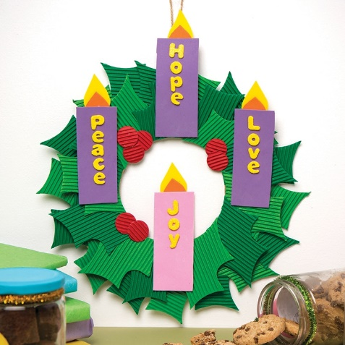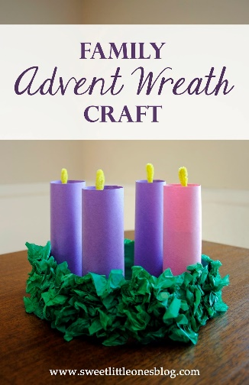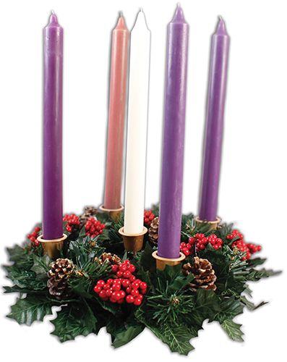  
Please do not include Santa, elves, or any non-Christian images.

Reception Homework - Due back Monday 24th November 2024

As part of our RE topic, the children have been thinking about the countdown to Jesus’ birthday.

During Advent we mark the countdown to Christmas with an Advent wreath.

For homework make an advent wreath to bring in and share with the class. This can be made from natural materials or can be a craft wreath. Talk to your child about the significance of the different candles and what they represent.

  
Please do not include Santa, elves, or any non-Christian images.