Advent Term 2 Planning Overview 2024
Our school grounds and local area. Nocturnal animals. Winter.

 | 4/11/2024 |  | 11/11/24 |  |  |  | 18/11/24 |  |  | 25/11/24 |  |  |  | 2/12/24 |  | 9/12/24 |  |  | 16/12/24
Weekly cycle | 1 |  | 2 |  |  |  | 1 |  |  | 2 |  |  |  | 1 |  | 2 |  |  | 1
 | 1st November  All Saints Day  Diwali 1st November  Bonfire Night 5th November |  | Remembrance Day 11th November  12th November  Anti-bullying week – choose respect  13th November  EYFS open afternoon/evening – show our best. |  |  |  | Friday - Youth Fun day Feast of Christ the King |  |  | Friday 29th whole school Mass  30th November  St Andrews day  First Sunday of Advent |  |  |  | Assessment week  Friday 6th Christmas Fair  Second Sunday of Advent |  | Assessment week  Friday 13th December Christmas Panto  Third Sunday of Advent |  |  | Wednesday 18th  EYFS Carol singing in the hall. Performance to parents  Fourth Sunday of Advent
Weekly Topics | Bonfire  Diwali |  | Remembrance  Antibullying |  |  |  | Nocturnal animals |  |  | St Andrew  Our local area and school grounds |  |  |  | Our local area and school grounds |  | Christmas story/Nativity |  |  | Christmas story/activities
 | Conservation  Social Justice  Community  Movement of People Farming  Cultural similarities and differences  Keeping safe and healthy |  | Conservation  Social Justice  Community  Movement of People  Farming  Cultural similarities and differences  Keeping safe and healthy |  |  |  | Conservation  Social Justice  Community  Movement of People  Farming  Cultural similarities and differences  Keeping safe and healthy |  |  | Conservation  Social Justice  Community  Movement of People  Farming  Cultural similarities and differences  Keeping safe and healthy |  |  |  | Conservation  Social Justice  Community  Movement of People Farming  Cultural similarities and differences  Keeping safe and healthy |  | Conservation  Social Justice  Community  Movement of People  Farming  Cultural similarities and differences  Keeping safe and healthy |  |  | Conservation  Social Justice  Community  Movement of People Farming  Cultural similarities and differences  Keeping safe and healthy
RE  Prophecy and Promise | The angel visited Mary with an important message | The angel visited Mary with an important message |  |  |  |  |  | Advent is a time to get ready for Christmas |  | Mary and Joseph travelled to Bethlehem. |  |  | Jesus was born in a stable. |  |  | The angels told the shepherds to visit Jesus. |  |  | The shepherds visit Jesus.
Catholic Social Teaching - Family and Community | My family at home | Prayer |  |  |  |  |  | My school family |  | Prayer |  |  | We are all different and we love and care for each other |  |  | Prayer |  |  | We love and look after each other because we are all brothers and sisters in God’s family.
Prayer and Liturgy.

FS1 and FS2 singing Christmas songs linked to the Nativity. Singing traditional carols – Away in a Manger and Little Donkey.
White Rose topic | It’s Me 123 |  |  |  |  |  |  |  |  | Light and Dark |  |  |  |  |  |  |  |  | Consolidation and assessment
Mathematics FS2 | Representing 1,2,3  Comparing 1,2,3  Composition 1,2,3 |  | Representing 1,2,3  Comparing 1,2,3  Composition 1,2,3 |  |  |  | Circles and triangles  Positional language |  |  | Representing numbers to 5 |  |  |  | 1 more and less |  | Shapes with 4 sides  Time |  |  | Assess
Mathematics FS1 | Number and Number patterns  Children will be developing their number understanding and skills in a variety of ways, both through discrete teaching and practical activities We will enjoy number songs and stories. The continuous provision allows for children to explore numbers and create and solve their own mathematical problems. The focus this half term will be touch counting.  Shape, Space and Measure  Children will take part in lots of practical activities involving shape and measure in all areas of the nursery (eg sand pit, water tray, construction area) This will help to develop the language and understanding of size and shape. We will encourage the children to make comparisons between different objects. The focus this half term will be 2D shapes
Mathematics FS1 | Touch counting fruit and milk - snack time activity  Talk about and recognise 2D shapes around us |  |  |  |  |  | Touch counting in our play - free flow adults to model and encourage  We’re going on a shape hunt… (inside) |  |  | Counting out a given number - circle time activity  Creating pictures using 2D shapes |  |  |  |  |  | Counting objects and match to given numbers - circle time activity  We’re going on a shape hunt … (outside) |  |  | Consolidation of learning - end of term assessments
Phonics FS2 | Unit 5 k,l,r,u |  |  |  |  |  | Unit 6 j, w, z |  |  |  |  |  |  | Assessments |  | Unit 7 x, y, ff, ll, ss, zz
Phonics FS1 | Rhythm and rhyme  Main Purpose: To experience and appreciate rhythm and rhyme and to develop awareness of rhythm and rhyme in speech. To increase awareness of words that rhyme and to develop knowledge about rhyme. To talk about words that rhyme and to produce rhyming words.
Literacy FS2 | Bonfire night writing. Writing cvc words and some common exception words |  |  | Owl Babies - phonic focus To blend and CVC words, simple labels, to recognise initial sounds, to ask questions. |  |  |  |  |  | Percy and the Park Keeper - labels, phonic focus CVC, simple labels encourage questioning, applying our phonic knowledge to write simple sentences  To read CVC words containing known letter-sound correspondences.  To know how to write captions.  One Snowy Night by Nick Butterworth |  |  |  |  |  | The Christmas Story - Nativity  To know how to write lists and simple letters.
Literacy FS1 | Painting - easel - firework inspired  Firework Song |  |  | Owl Babies – listen to the story and act out using props and puppets. |  |  |  |  |  | One Snowy Night by Nick Butterworth |  |  |  |  |  | The Christmas Story  Links with RE
Communication & Language FS2 | Bonfire role play  Log pile, round of tree stumps. |  |  | Nocturnal animals roleplay, puppets, set, den, burrow etc |  |  |  |  |  | Park roleplay – animal puppets, gardening tools etc |  |  |  |  |  | Imagination. Role-play, making up own stories using the grotto
Communication & Language FS2 | Retelling the story, taking turns to say the next line, retelling as a group, extending with CT support |  |  |  |  |  |  |  |  |  |  |  |  |  |  | Santa’s grotto/Nativity outdoors
Nursery rhymes and action rhymes | FS2  (alongside previously taught nursery rhymes)  I’m A Little Teapot  The Grand Old Duke Of York  Ring O’ Roses  Hickory Dickory Dock  The ABC Song
Communication & Language FS1 | Talk about our Bonfire night experiences - circle time activity. |  |  | See FS2 |  |  |  |  |  | See FS2 |  |  |  |  |  | See FS2
Nursery rhymes and action rhymes | FS1  (alongside previously taught nursery rhymes)  Incy wincy  Old McDonald  Hickory Dickory Dock  The grand old duke of York  Clap your hands
Understanding of the World FS2 and FS1 | Diwali  Bonfire/  week activities |  |  | Remembrance |  | Nocturnal animals  Sorting nocturnal and diurnal animals. |  |  |  | Become familiar with the school grounds and local area.  See separate planning |  |  | Orienteering using a map of the school grounds and surrounding roads. |  |  | Christmas activities – cards, calendars, peppermint creams and baskets
Understanding of the World FS2 and FS1 | Seasons: Autumn to Winter - walk and observe, discuss, share, question
Expressive  Arts & Design FS2  Structures: Junk modelling - Kapow Primary | Exploring junk modelling  To explore and investigate the tools and materials in the junk modelling area. |  |  |  | Cutting and scissor skills  To develop scissor skills.  To investigate cutting different materials. |  |  |  | Choosing resources  To learn how to plan and select the correct resources needed to make a model. |  |  | Making models  To verbally plan and create a junk model. |  |  | Evaluation and presentation  To share a finished model and talk about the processes in its creation. |  |  | Temporary joins  To explore different ways to temporarily join materials together.
 | Charanga – Responding to stories through dance, drama and music.
Expressive Arts and Design FS1 | Creating with Materials The children will have continuous access to a making area with a wide range of open-ended resources to practice and hone their creative skills.  Being Imaginative and Expressive We will help children to develop their ability to explore different ways of expression through singing, dancing and imaginative play. We will also provide open-end resources so that the children have the opportunity to use and develop their imagination. |  |  |  |  |  |  |  |  |  |  |  |  | Seasonal Projects Kapow
Physical  Gross motor  Outdoor FS2 | Games Unit 2 Focus on using a ball – Val Sabin Planning
Physical  Gross motor  Indoor FS2 | Dance Unit 1 Stars in Space, Rabbits, Follow my Leader, Hickory Dickory Dock, Autumn Leaves - Val Sabin Planning
Fine motor FS2 | Playdough disco  Dough and glitter  Bonfire themed cutting tasks.  Rocket trace the dotted line.  Slime and stars  Rangoli art with pasta and rice.  Mendi art  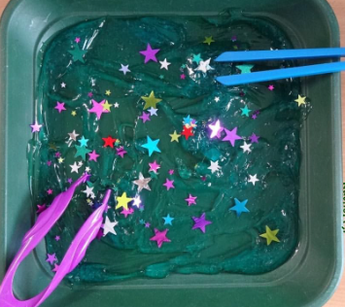 |  | Making patters with colourful cotton buds.  Nuts and bolts  Remembrance themed cutting.  Using peg boards to make a poppy  Hammer bead poppy  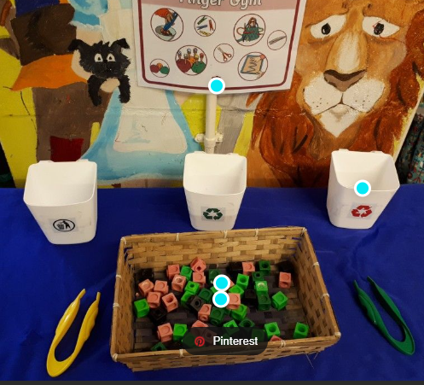 |  |  |  | Magnets  Making shapes with magnetic construction.  Paper clip chains  Shape threading  Rescue animals in elastic bands.  Pegging numbers onto hedgehogs  Nocturnal animal paint dobbers with cotton buds. |  |  |  | Penne pasta threading  Pegs on numbers to 5  Snow painting with pompoms and pegs (blue card and white paint)  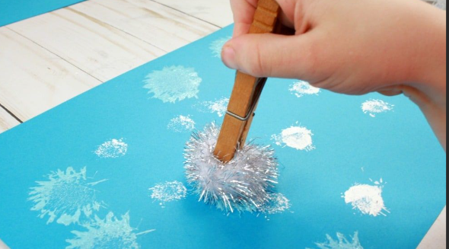 |  |  | Snowman playdough  Roll the dice and feed the tennis ball.  Winter themed cutting  Snowman bottle cotton bud and tweezers  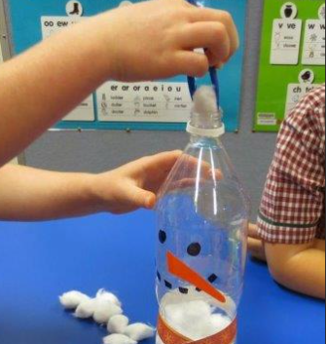 |  |  | Dot stickers on Christmas tree shapes.  Small pieces/ small parts  Making fat balls for birds.  Pinecones in elastic bands.  Snowflake bead threading  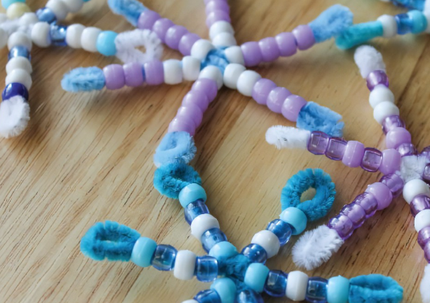 |  | Christmas crafts, shape tree cutting.  Cotton bud paint dots on trees.  Pompom and tweezer – decorate a tree shape.  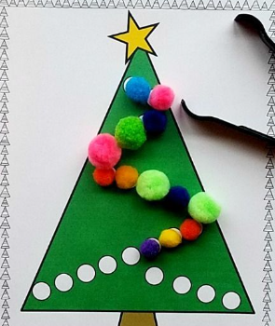
Physical Development FS1  Fine Motor | The children will continue to develop their fine motor skills; they will have continuous access to daily fine motor activities, that will support their fine motor skills, hand eye coordination and hand strength.  *Twice a day the children take part in an adult led fine motor activity. (As a group)  See further planning for activity ideas.
Physical Development  Gross Motor FS1 | Children will continue to develop their gross motor skills through outdoor play; running, climbing, balancing, crawling etc  They will develop their ability to move safely too, developing core muscle strength, stability, coordination and balance. This will also involve negotiating obstacles and using wheeled toys and climbing equipment.  Focus this half term: Riding wheeled vehicles safely and with control.

