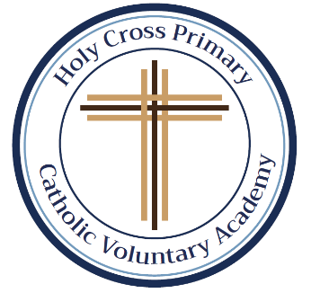Please find attached all of the spellings for this half-term. As you will see, most of them are Common Exception Words (CEW). As we progress down the pyramid, the same words will keep appearing. This is so your child will grow in confidence by being able to recognise and apply the words in their work. We will begin this week with some familiar words. Please support your child by using the CEW flash cards, sent out before the half-term, to help them learn their spellings. All spellings will be added to our class page under the spellings tab. If you require any further information, help or support, please do not hesitate to contact me. **Words that have been highlighted in green are from the Year 3 and 4 Common Exception word list** Thank you as always. Miss Duong.

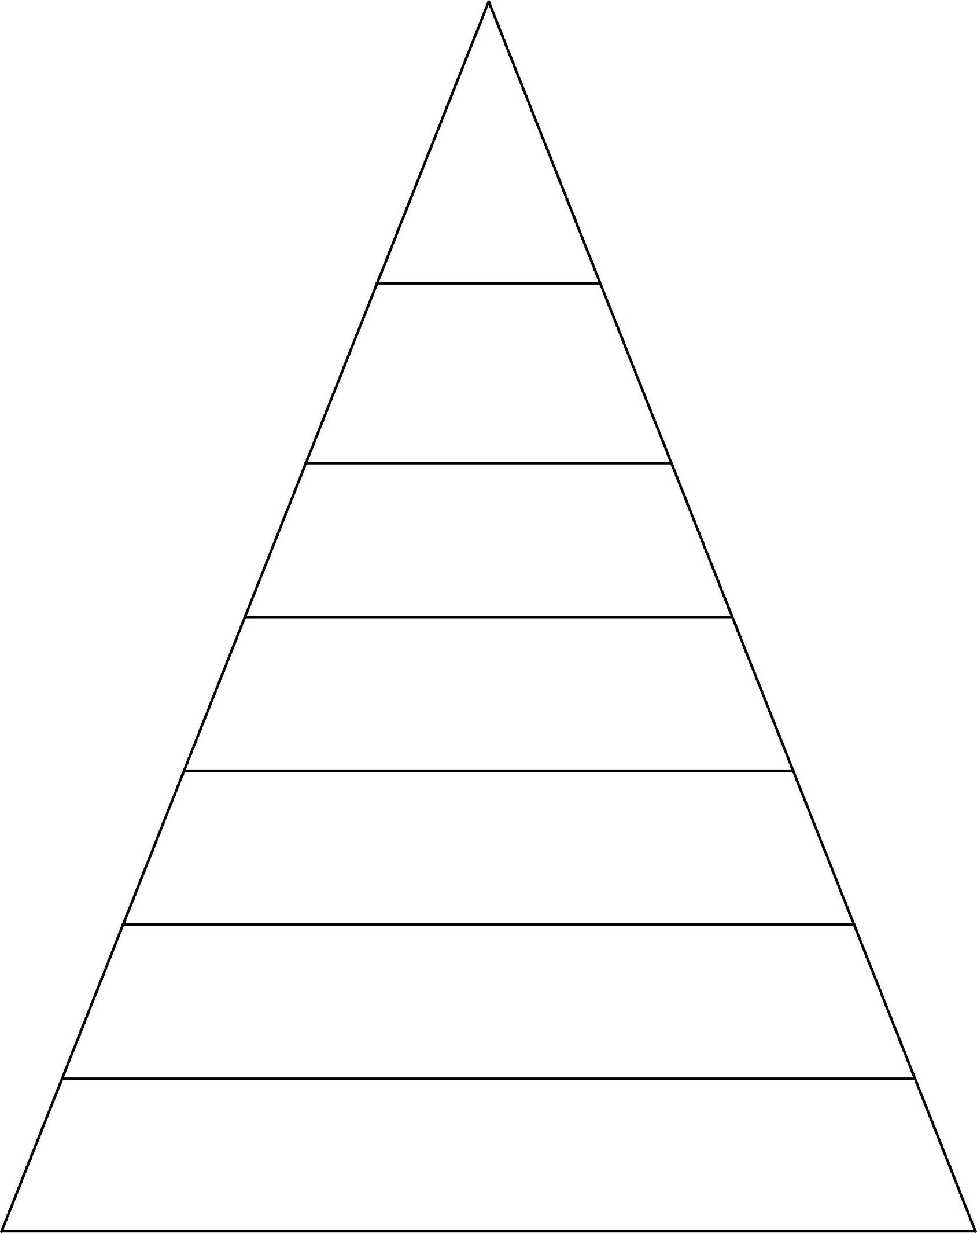

busy every water because children climb only both Jesus Christmas break pretty beautiful after father move improve

sure sugar eye should would who whole clothes people everybody although

busy every water because children

climb only both Jesus Christmas break

pretty beautiful after father move improve

sure sugar eye should would

although believe disappear

busy every water because children climb only both Jesus Christmas break pretty beautiful after father move improve sure sugar eye should would who

busy every water because children climb only both Jesus Christmas break pretty

beautiful after father move improve sure

busy every water

because children climb

only both Jesus Christmas break pretty

busy

every

water

because

children

busy every

water because

children climb

only both

**Week 6 Spellings for Friday 9th December 2022 – 28 spellings**

**Group 3**

**Week 1 Spellings for Friday 4th November 2022**

**5 spellings**

**Week 7 Spellings for Friday 16th December 2022 – 30 spellings**

**Week 5 Spellings for Friday 2nd December 2022 – 23 spellings**

**Week 4 Spellings for Friday 25th November 2022 –**

**18 spellings**

**Week 3 Spellings for**

**Friday 18th November 2022 -**

**12 spellings**

**Week 2 Spellings for**

**Friday 11th November 2022 –**

**8 spellings**