Please find attached all of the spellings for this half-term. As you will see, most of them are Common Exception Words (CEW). As we progress down the pyramid, the same words will keep appearing. This is so your child will grow in confidence by being able to recognise and apply the words in their work. We will begin this week with some familiar words. Please support your child by using the CEW flash cards, sent out before the half-term, to help them learn their spellings. All spellings will be added to our class page under the spellings tab. If you require any further information, help or support, please do not hesitate to contact me. Thank you as always. Miss Duong.

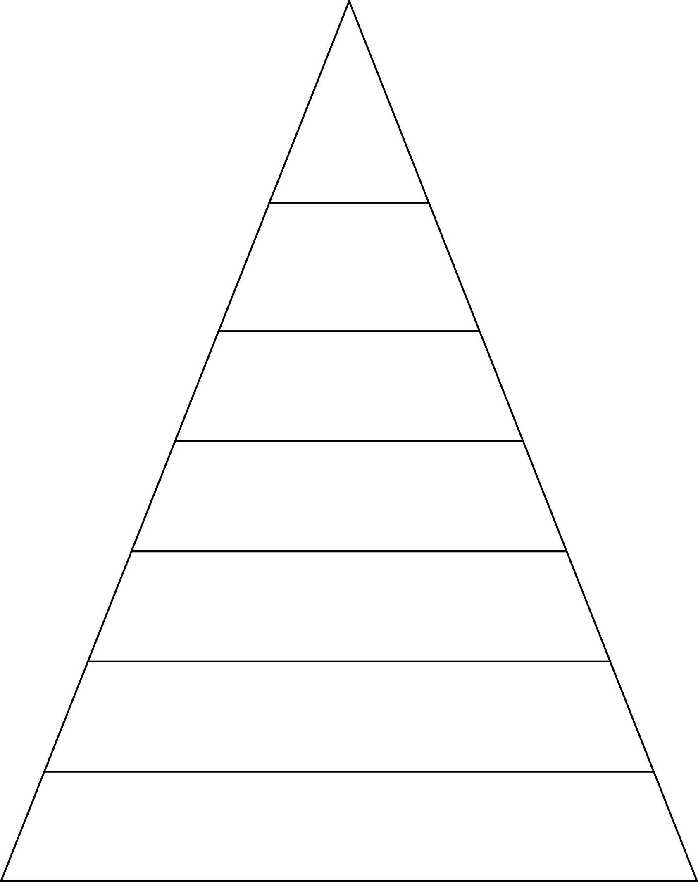

our looked when great what could says

little called asked people love Mr Mrs

where your friend today their house Jesus because pretty every father Christmas break after

who sure

**Week 6 Spellings for Friday 9th December 2022 – 28 spellings**

**Group 2**

**Week 1 Spellings for Friday 4th November 2022**

**5 spellings**

our looked when great what could says

little called asked people love Mr Mrs

where your friend today their house

Jesus because pretty every father

Christmas break after

our looked when great what could says little called asked people love Mr Mrs where your friend today their house Jesus because pretty

our looked when

great what could says little called asked

people love

our looked

when great

what could

says little

**Week 7 Spellings for Friday 16th December 2022 – 30 spellings**

**Week 5 Spellings for Friday 2nd December 2022 – 23 spellings**

**Week 4 Spellings for Friday 25th November 2022 –**

**18 spellings**

**Week 3 Spellings for**

**Friday 18th November 2022 -**

**12 spellings**

**Week 2 Spellings for**

**Friday 11th November 2022 –**

**8 spellings**

our looked when great what could says little called asked

people love Mr Mrs where

your friend today

great

our

looked

when

great

what