Please find attached all of the spellings for this half-term. As you will see, most of them are Common Exception Words (CEW). As we progress down the pyramid, the same words will keep appearing. This is so your child will grow in confidence by being able to recognise and apply the words in their work. We will begin this week with some familiar words. Please support your child by using the CEW flash cards, sent out before the half-term, to help them learn their spellings. All spellings will be added to our class page under the spellings tab. If you require any further information, help or support, please do not hesitate to contact me. Thank you as always. Miss Duong.

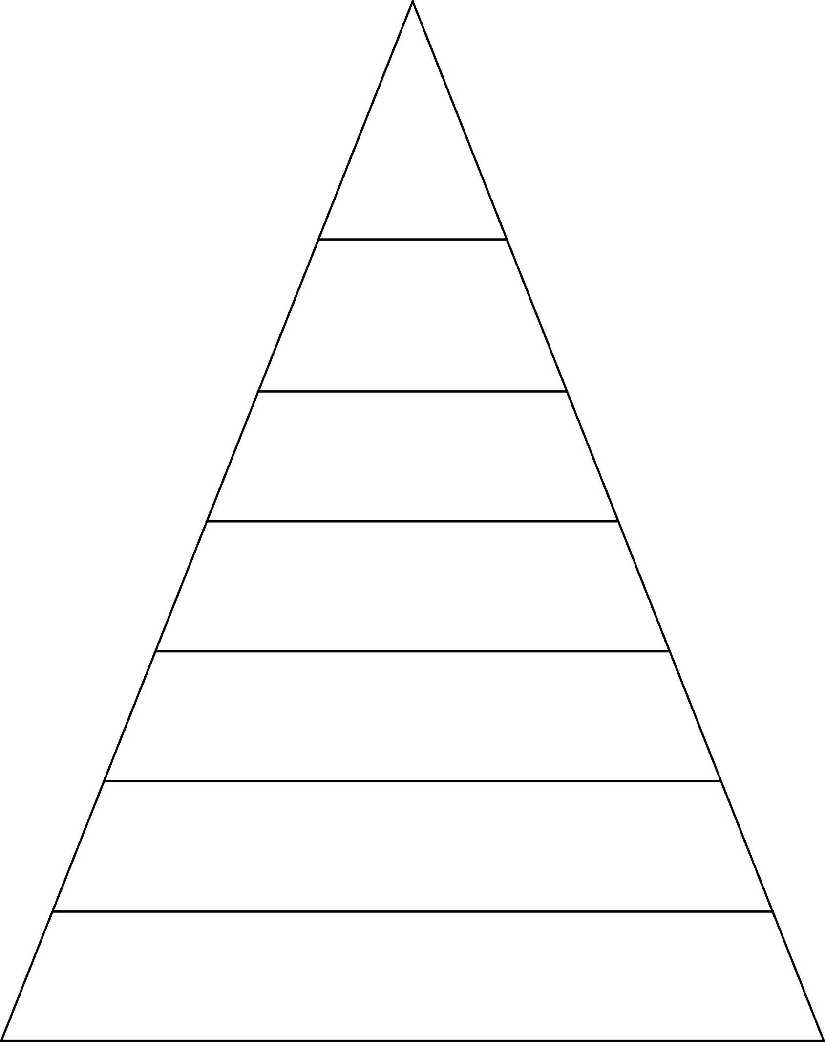

I to no go into is are

do so the are said by

of says were his be he

me she we my ask love put

come some

I to no go

into is are do

so the are said

I to

no go

into is

are do

I to no go into is are

do so the are said by

of says were his be he

me she we my ask love put

come some our push

**Week 6 Spellings for Friday 9th December 2022 – 28 spellings**

**Group 1**

**Week 1 Spellings for Friday 4th November 2022**

**5 spellings**

I to no go into is are

do so the are said by

of says were his be he

me she we my

**Week 7 Spellings for Friday 16th December 2022 – 30 spellings**

**Week 5 Spellings for Friday 2nd December 2022 – 23 spellings**

**Week 4 Spellings for Friday 25th November 2022 –**

**18 spellings**

**Week 3 Spellings for**

**Friday 18th November 2022 -**

**12 spellings**

**Week 2 Spellings for**

**Friday 11th November 2022 –**

**8 spellings**

I to no go into is

are do so the are

said by of says were

his be

I

to

no

go

into