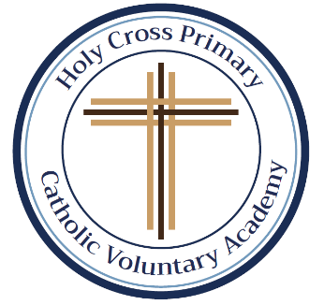In this first half-term, all the children will get the same spellings as they get used to the number of spellings to be tested each Friday. As you will see, most of them are Common Exception Words (CEW). As we progress down the pyramid, the same words will keep appearing. This is so your child will grow in confidence by being able to recognise and apply the words in their work. We will begin this week with some familiar words from Year 1. Please support your child by using the CEW flash cards, sent out at the beginning of the half-term, to help them learn their spellings. All spellings will be added to our class page under the spellings tab. If you require any further information, help or support, please do not hesitate to contact me. Thank you as always. Miss Duong.

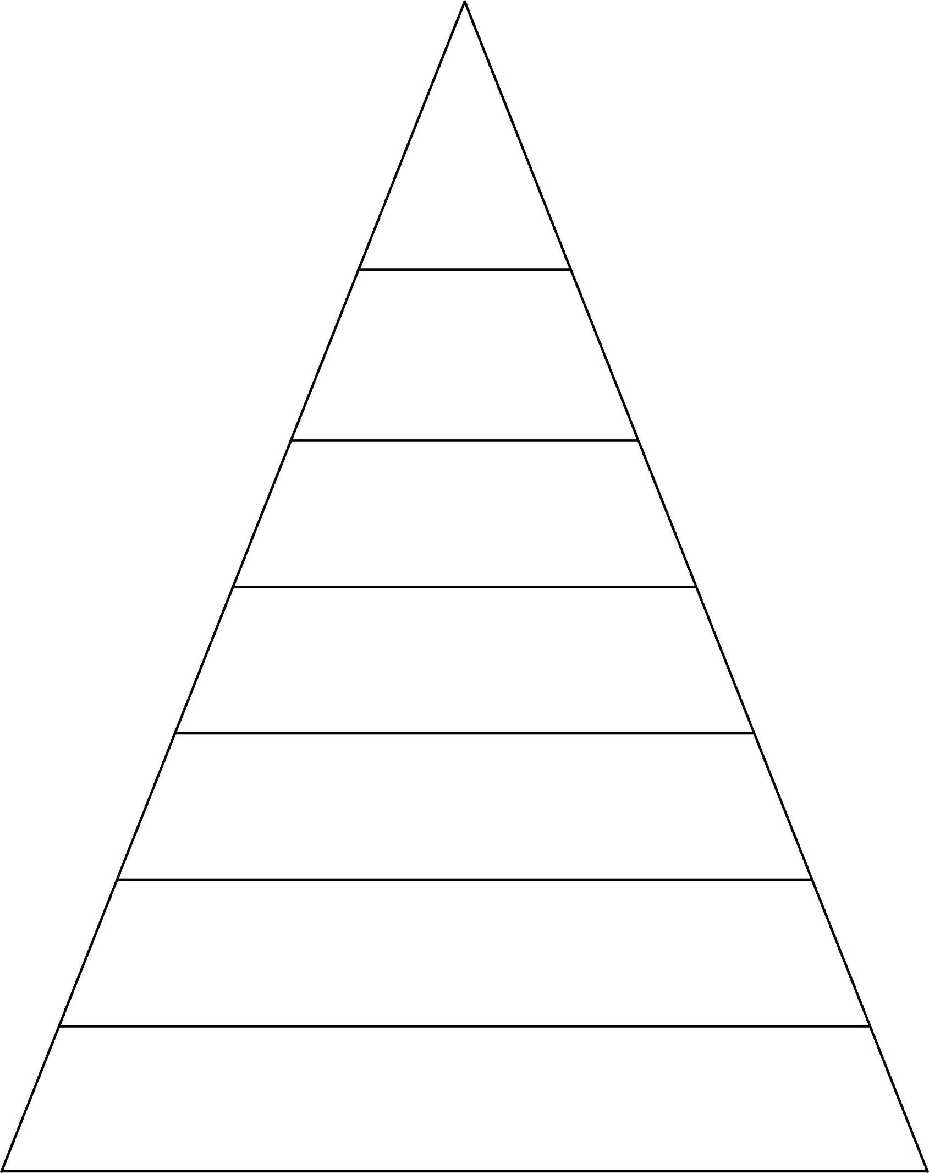

**Week 6 Spellings for Friday 20th October 2023 – 35 spellings**

**Week 5 Spellings for Friday 13th October 2023 – 30 spellings**

**Week 4 Spellings for Friday 6th October 2023 – 23 spellings**

**Week 3 Spellings for**

**Friday 29th September 2023 – 17 spellings**

**Week 2 Spellings for**

**Friday 22nd September 2023 – 11 spellings**

**Week 1 Spellings for**

**Friday 15th September 2023 – 5 spellings**

was they all are said have like do

some were come there little one when out what great oh their people

Mr Mrs looked could called asked today says your where love once ask friend

was they all are said

have like do some were come

there little one when out what

great oh their people Mr Mrs

was they all are said

have like do some were come there little one

when out what

**October half-term, no spellings until Friday 10th November 2021**

was they

all are

said

was they

all are said

have like do

some were come

was they all are said have like do some

were come there little one when out what

great oh their people Mr Mrs looked

could called asked today says your