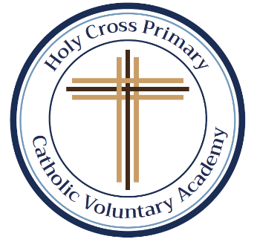
In this first half-term, all the children will get the same spellings as they get used to the number of spellings to be tested each Friday. As you will see, most of them are Common Exception Words (CEW). As we progress down the pyramid, the same words will keep appearing. This is so your child will grow in confidence by being able to recognise and apply the words in their work. We will begin this week with some familiar words from Year 1. Please support your child by using the CEW flash cards, sent out at the beginning of the half-term, to help them learn their spellings. All spellings will be added to our class page under the spellings tab. If you require any further information, help or support, please do not hesitate to contact me. Thank you as always. Miss Duong.
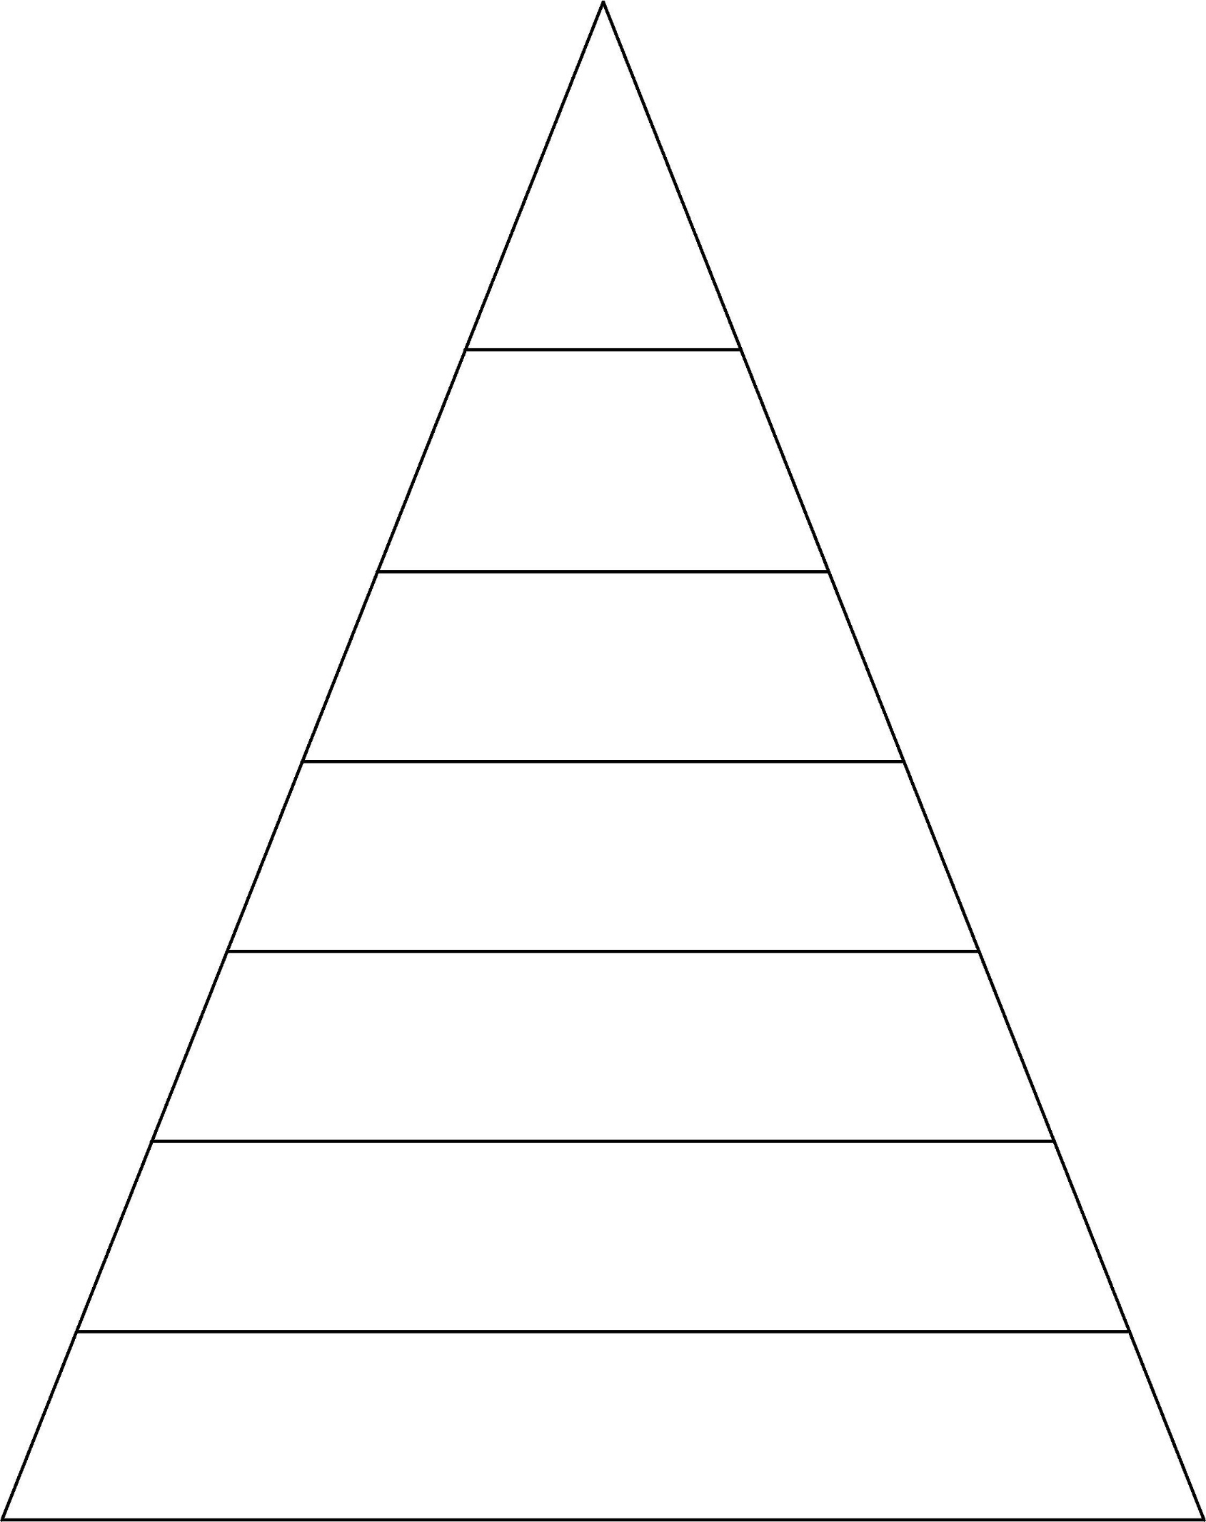
Week 6 Spellings for Friday 14th October 2022 – 35 spellings
Week 5 Spellings for Friday 7th October 2022 – 30 spellings
Week 4 Spellings for Friday 30th September 2022 – 23 spellings

Week 3 Spellings for
Friday 23rd September 2022 – 17 spellings

Week 2 Spellings for
Friday 16th September 2022 – 11 spellings

Week 1 Spellings for
Friday 9th September 2022 – 5 spellings
was they all are said have like do some were come there little one when out what great oh their people Mr Mrs looked could called asked today says your where love once ask friend

was they all are said
have like do some were come
there little one when out what
great oh their people Mr Mrs loollingsked

was they all are said
have like do some were come there little one
when out what

October half-term, no spellings until Friday 4th November 2021

was they
all are
said

was they
all are said
have like do
some were come

was they all are said have like do some were come there little one when out what great oh their people Mr Mrs looked could called asked today says your

