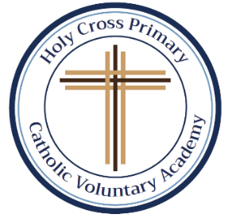[](https://www.google.co.uk/url?sa=i&rct=j&q=&esrc=s&source=images&cd=&cad=rja&uact=8&ved=0ahUKEwjvxp_yicrVAhXlCMAKHbIvDn8QjRwIBw&url=https://101clipart.com/christian-family-clipart/&psig=AFQjCNH9OiJWNhUlmofSbOZT1NEKfeylUw&ust=1502365485491314)**Holy Cross Primary**

[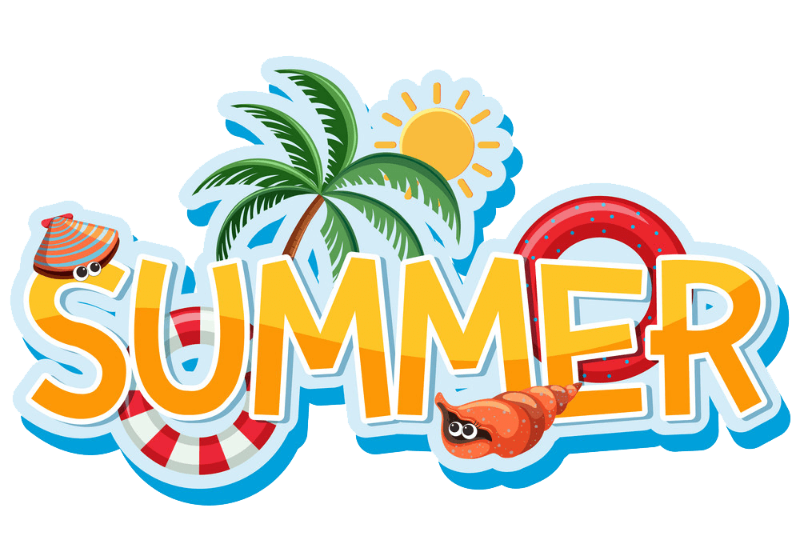](https://www.google.co.uk/url?sa=i&url=https%3A%2F%2Fclipart.world%2Fsummer-clipart%2Fsummer-clipart-transparent%2F&psig=AOvVaw27SchhixH8zWzwkwAKxTZi&ust=1617979699883000&source=images&cd=vfe&ved=0CAIQjRxqFwoTCKD5l6Hy7u8CFQAAAAAdAAAAABAb)**Catholic Voluntary Academy**

[](https://www.google.co.uk/url?sa=i&url=https%3A%2F%2Fwww.acommunityofgrace.org%2Fmessages%2F2019%2F6%2F9%2Fpentecost-sunday&psig=AOvVaw1kV5fV8kUHWmSq7yekiMLW&ust=1617979361878000&source=images&cd=vfe&ved=0CAIQjRxqFwoTCLCsioLx7u8CFQAAAAAdAAAAABAD)

I hope you all had a fantastic, happy and relaxing break over the Easter period. Last Lent Term was very busy and very different in many ways. We are now in the last term of Year 2 and KS1 and will continue our hard work to achieve our best.

**Our topic for the Pentecost Term is ‘Kings and Queens’ and ‘Coastlines’. We will be focusing on the history of the monarch and King Charles IIIs coronation. This is an exciting time in history and links to The Queen’s Platinum Jubilee celebrations we had in school last year. We will also focus on coastlines, what they are, and which coastlines are the closest to Hucknall. As always, we will also try to make cross-curricular links to other areas of learning such as English, music, art and D&T if possible.**



Our **Come and See** topics this term are ‘Spread the Word’, ‘Rules’ and ‘Treasures’. 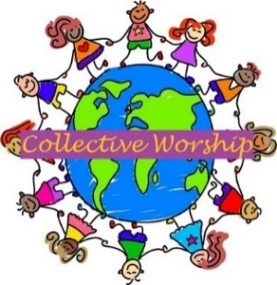

In ‘Spread the Word’, we shall begin by looking at how we pass messages, how they make us feel and who is responsible. We shall be learning about the special news the women told the disciples. We shall specifically be looking at the Holy Spirit and ways the Holy Spirit helps the friends of Jesus, how we spread the Good News of Jesus’ love and what happens on Pentecost Day. In our ‘Rules’ topic, our work will include looking at rules; what they are, why we have them, what happens if we don’t follow them and if there are good and bad rules. We will look at what St Paul says and what is important in his scripture. We will follow up on good and bad choice which links to one of our previous topics, Opportunities. We will also focus of the Sacrament of Reconciliation, what happens in church and what Jesus’ rule was for daily life and how He shows his love for us and how we give each other the sign of peace. In our final topic for Year 2, ‘Treasures’, we shall be looking at our CAFOD topic of God’s wonderful world, special places in the world, how to look after God’s world and how we can appreciate the gift and treasure from God and the beauty of His world that He has given to us to share with one another. We will also talk about, ask questions and wonder about our own experiences and feelings about the treasures we have and see. We will also focus on what we treasure and why.

We will have regular Collective Worships which the children will help to plan, lead and evaluate. These will be based on our Come and See topics, as well as personal, social and emotional and physical development. 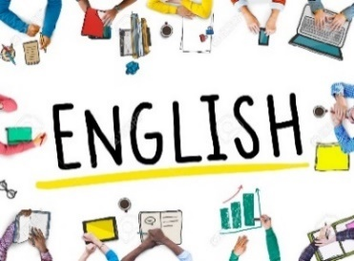

In **English** we shall be looking at stories linked to our topic, of coastlines focusing on the story of Flotsom which is a book without words. The story will help the children to use their imagination and write a story for the pictures in this book. We will also read stories about Kings and Queen’s looking at The Queen’s knickers and looking to see if there are now stories linked to King Charles. We will also access and use non-fiction books from the Educational Library to enhance our learning too. We continue to focus on our non-fiction writing such as instructional writing, non-chronological reports, poetry and then back to story language and narrative writing focusing on our writing to ensure we include the correct punctuation and spelling.

Children will be reading daily as a class and carrying out an independent reading tasks, or reading with myself or Miss Turner 1-1. We will have a big focus on reading VIPERS. We use VIPERS as it helps us with our reading. It stands for Vocabulary, Infer, Predict, Explain, Retrieve, Sequence. We will also have daily Phonics sessions which will include SPAG – Spelling, Punctuation and Grammar - and handwriting sessions to focus on letter formation. This term we will be focusing on apostrophes; possessive and contractions.

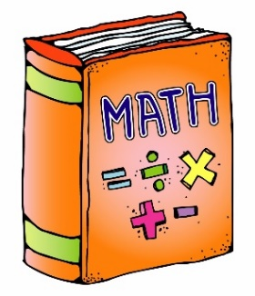

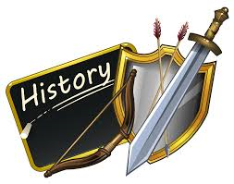In **Maths** we shall continue to follow the New National Curriculum and follow White Rose’s Small Steps but will have lots of fun putting our learning into the context of our topic. This term, we will begin with a quick recap of all of the topics we learnt in the Advent and Lenten term. We will also learn about fractions, time, statistics, positional and direction too. We will also continue to embed place value and number, addition and subtraction, multiplication and division, reasoning and problem solving and consolidate any misconceptions to support your child as they move to Key Stage 2, Year 3. Children can continue to learn their times tables by logging onto their Times Table Rockstars account and develop their development of speed and fluency to apply number facts to all aspects of maths. They will also continue to apply their skills concretely, pictorially and abstractly ensuring that they are fluent in their skills before they are able to reason and solve problems.

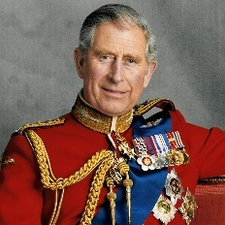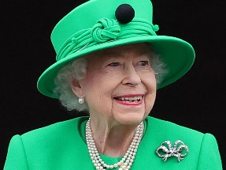In **History**, we shall be learning about the life of another significant individual from the past and events beyond living memory, looking at King’s and Queen’s and the Royal Family. This will now play a big part in our lives as we transition from Queen Elizabeth II to King Charles III’s reign. We will learn about members of the Royal Family, how they become a monarch and their family tree. We will also celebrate the Coronation in school to mark another historical event.

In **Geography**, our topic will focus on coastlines. We will also continue to focus and recap on geographical elements we have already learnt, such as, human and physical features, continents and oceans, directions and compass directions, map skills but also learn the definition of a coastline, use maps to identity the closest coastline to Hucknall and look at how coastlines are formed.

In both D&T and Art, we will continue to use out Kapowunits of learning. In **Design & Technology,** the children will be looking at mechanisms and a fairground wheel; designing, planning, making and evaluating their Fairground Wheel. In **Art** we shall be looking at the unit painting and mixing media; life in colour and linking this to our geography topic of coastlines, looking at some seaside/coastline artwork by **Van Gogh** and **Monet**. We will explore different textures and collage techniques to create our artwork and evaluate our work at end too.

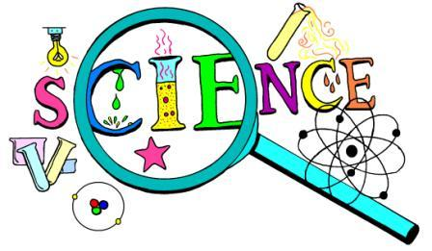In **Science** we shall be learning about ‘Plants’, the children will observe and describe how seeds and bulbs grow into mature plants and find out and describe how plants need water, light and a suitable temperature to grow and stay healthy. The children will be working scientifically throughout both units and asking and answering question by scientific enquiry and investigation including collecting and analysing data. We will also continue to monitor how our tomato seeds have grown from the Lenten term and plant our wheat seeds this term too. We shall also be learning about ‘Animals, including humans; Living Things’ and taught the following: notice that animals, including humans, have offspring which grow into adults, find out about, and describe the basic needs of animals, including humans, for survival (water, food and air), describe the importance for humans of exercise, eating the right amounts of different types of food, and hygiene.

We shall have lots of fun with music, exploring instruments, including our voices and how to make music with our body such as our hands and feet. We shall also be learning about long and short sounds, pitch and beat and how to do this with our body and instruments. We will continue our singing sessions with Mr Davis on a Friday morning too.

In **PE,** we shall continue our lessons with Mr Priestley and be learning fundamental skills to help us play games such as ball skills, hand and eye co-ordination, dribbling, kicking and hitting, group games, rules and inventing rules too. This will enable us to understand certain games and how to play them. We will also focus on athletic skills take offs and landing, running for even pace, underarm throw for accuracy and distance, underarm, overarm and push throws and relays, as well as take part in our Sports Day too.

Please ensure that your child comes to school in a suitable PE kit; plain navy joggers, jumpers and plain white/dark t-shirt, no logo or patterned sportswear on our named PE days. Thank you.

**Note PE days this term will continue to be on a Monday. Please also ensue that your child does not come to school wearing earrings on a PE day. Thank you**

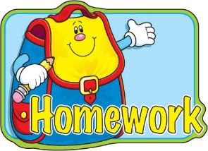

**Homework**

The children will have on-going homework such as weekly spellings, knowledge organisers, as well as homework that needs to be completed and handed in such as the Explore homework for Come and See. Homework will help and support to consolidate your child’s learning. Part of your child’s weekly homework will be to complete the following tasks;

* **Spelling Shed** games are available so please log on for 10 minutes a week. This will support and embed your child’s reading and spelling of words.
* **TTRS** – Times Table Rock Stars – log on as and when you can, even if just for 10 minutes a week to practice your times tables.
* **Knowledge Organisers, KOs** – new Kos are added to the class page of the school website at the beginning of each half-term. Please spend 10 minutes a week looking at these, as well as the vocabulary on them during our lessons.
* **Spellings** – all of spellings will be added under the ‘Spellings’ tab on our class page****. The children are always given a paper copy too.

**Diary Dates**

Here are just a few dates for your diary, please see the electronic diary on the school website as there are even more dates of what’s happening in school between now and the end of term. Thank you.

**Class Mass –** Friday 21st April 2023 at 9:30am. All parent and carers are welcome.

**Hucknall Library Visit –** Wednesday 26th April 2023 – please let me know if you are able to walk us to the library.

**May Bank Holiday –** Monday 1st May 2023 – school closed.

**Trip to Pizza Express at Giltbrook Retail Park, Nottingham –** Wednesday 3rd May 2023 – **we will be leaving school at 8:45am prompt** so all children need to be ready and toileted so we can be on our way for 8:45am. Please ensure that you are in school at 8:30am. I will ensure that the bottom gate is open 5 minutes earlier on this day.

**King Charles IIIs Coronation Day Celebrations –** Friday 5th May 2023 – further details will be sent out in a letter nearer the time.

**Extra May Bank Holiday for King Charles IIIs Coronation –** Monday 8th May 2023 – school closed.

**May half –term –** 1 week – break up on Friday 26th May 2023 return to school on Monday 5th June 2023.

If you have any questions or concerns about anything at all, please do not hesitate to contact me by sending me a message on Class Dojo and I will look to answer any queries as quickly as possible.

Please ensure that you keep up-to-date with homework, spellings, news, events and dates for your diary by checking our class page/Class Dojo or the school website, Calendar section regularly.

Thank you in advance for your help and support, as always,

**Miss Duong**