[](https://www.google.co.uk/url?sa=i&rct=j&q=&esrc=s&source=images&cd=&cad=rja&uact=8&ved=0ahUKEwjvxp_yicrVAhXlCMAKHbIvDn8QjRwIBw&url=https://101clipart.com/christian-family-clipart/&psig=AFQjCNH9OiJWNhUlmofSbOZT1NEKfeylUw&ust=1502365485491314)**Holy Cross Primary**

**Catholic Voluntary Academy**

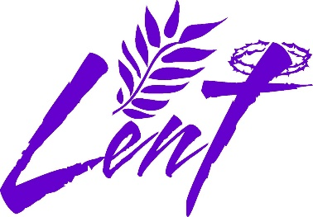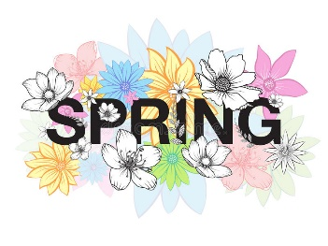

I hope you all had a fantastic, happy, and relaxing break over the Christmas period. Last Advent Term was very busy with lots of exciting events in and out of school including a trip to Carsington Water, the Carol service at St. Barnabas Cathedral in Nottingham, as well as our Nativity production. The children worked extremely hard to adapt to our temporary classroom as well as moving back into our newly extended Year 2 class. I’m sure this Lent Term will also be very busy too.

**Our topic for the Lent Term is ‘Africa’ and ‘Farming’. We will look at this continent and some of the countries within it, human and physical features of Africa/UK and all about Nelson Mandela, traditional stories from different cultures, learn about animals, humans and living things, their habitats and life cycles. We will be linking our topic of farming in Africa and the UK to one of our seven school themes of Conservation. As always, we will also try to make cross-curricular links to other areas of learning such as English, music, art, and D&T. For example, our art will link to our geography topic of the Lake District and focus on Keith Melling’s painting of it.**



Our **Come and See** topics this term are ‘Books’, ‘Thanksgiving’ and ‘Opportunities’.

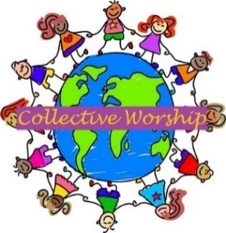In ‘Books’, we shall begin by looking at the different books used at home and in school. We shall be learning about the books used in Church on Sunday by the parish family. We shall specifically be looking at The Bible, describing how the Gospels are used and learning to retell the story of the baptism of Jesus. In our ‘Thanksgiving’ topic, our work will include looking at the different ways to say thank you; learning about The Eucharist as our opportunity to thank God for Jesus; retelling the story of the Last Supper and learning some ways in which Catholics can try to live what they have experienced in Mass in their daily lives. In ‘Opportunities’, we shall be looking at how each day offers opportunities for good; learning about Lent as an opportunity to turn towards what is good in preparation for Easter. We shall be retelling some of the events of Palm Sunday, Maundy Thursday, Good Friday, and Easter Sunday.

We will have regular Collective Worships and Class Masses which the children will help to plan, lead, and evaluate. These will be based on our Come and See topics, as well as personal, social, and emotional and physical development.

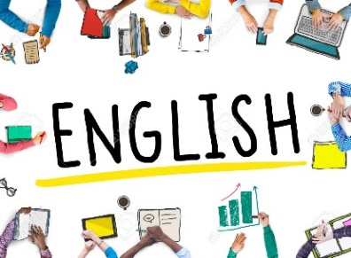In **English** we shall be looking at traditional stories from different cultures focusing on stories in Africa (Wangari’s Tree of Peace, Nelson Mandela Long Walk to Freedom, We’re going on a Lion Hunt, Sulwe to name a few); non-chronological reports; information texts (non-fiction) by looking at a selection of books to go with our Africa topic and focusing on our writing to ensure that we include the correct punctuation and spelling. We will also be looking at animal stories by Beatrix Potter which will link with our farming and conservation theme.

We will learn how to write diary entries, newspaper reports and focus on narrative writing too; character descriptions and planning a story.

Children will be reading daily as a class and carrying out an independent reading task or reading with an adult 1:1. We will also have daily Phonics sessions which will include SPAG – Spelling, Punctuation and Grammar - and handwriting sessions too to focus on letter formation and learning how to join their letters, cursive handwriting. Our phonics sessions will follow the Sounds Write Programme and will focus on retrieval practice and previous sounds that the children have already covered. Please ensure that they spend some time logging onto Spelling Shed to help with this.

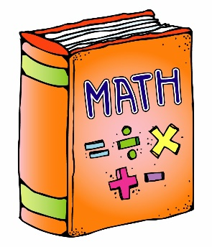

In **Maths** we shall continue to follow the New National Curriculum but will have lots of fun putting our learning into the context of our topic. This term, we will learn about money; counting money in pounds and pence, making the same amount with different coins, finding change, multiplication and division, length and height, mass, capacity, and temperature, and we will also continue to embed place value and number, addition and subtraction, reasoning and problem solving using our concrete objects. Children can continue to learn their times tables by logging onto their Times Table Rockstars account and develop their development of speed and fluency to apply number facts to all aspects of maths. They will also continue to apply their skills concretely, pictorially, and abstractly.

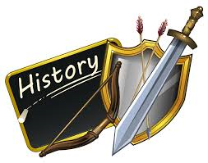In **History**, we shall be learning about the life of a significant individual from the past who have contributed to national and international achievements, looking at the life and work of Nelson Mandela using our book, Nelson Mandela Long Walk to Freedom.

We will also look at what life was like and how life may have changed and the impact that Nelson Mandela had on Africa and the world.

In **Geography**, we shall be looking at some of the countries in the continent of Africa and at some of the geographical features, human and physical, weather and animals native to some African countries. We will also identify seasonal and daily weather patterns in the location of hot and cold areas of the world in relation to the equator. We will also be looking at farming in the Lake District and the impact Beatrix Potter had on the UK, how she influenced what we have today and linking this to our curriculum themes of conservation and farming. This will also link with our CAFOD/Fairtrade Fortnight too.



In **Design & Technology,** the children will be following our Kapow Unit Textiles, puppets. In this unit, we will learn to join fabrics together using pins, staples, glue or by using thread to sew. They will design, create, and evaluate a puppet using their design and template. In **Art** we shall also be following our Kapow Unit titled Craft and design: Map it out. In this unit, the children will learn how to investigate the way maps can be real or imaginary; comparing features of maps as artworks; creating children’s maps in a chosen style and medium. They will develop drawing, painting, and sculpture skill, and looking at the artwork of artists, craft makers and designers between different practices and disciplines, and making links to their own work. They will also use a range of materials to design, make and evaluate products, and techniques in using colour, pattern, texture, line, shape, form, and space.

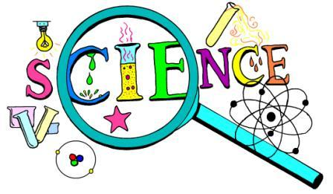In **Science** we will learn about ‘Living Things’. The children will explore and compare the differences between things that are living, dead, and things that have never been alive. They will identify that most living things live in habitats to which they are suited and describe how different habitats provide for the basic needs of different kinds of animals and plants, and how they depend on each other, identify and name a variety of plants and animals in their habitats, including microhabitats, describe how animals obtain their food from plants and other animals, using the idea of a simple food chain, and identify and name different sources of food. The children will be working scientifically throughout all science units and asking and answering question by scientific enquiry and investigation including collecting and analysing data.



We will continue our weekly Friday singing sessions with Mr Davis. We continue to focus long and short sounds, pitch, beat and tone, and many other elements which help and support us to be fantastic singers such as posture and breathing techniques. We will also embed and use the following terms: tempo, dynamics, tonality, and learning different music styles and genres, as well as singing techniques and performance skills.

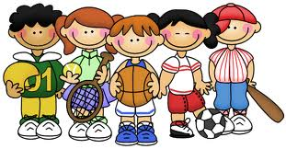We will continue our **PE** with Mr Priestley. This term, we shall be continuing with our Val Sabin units of learning and will focus on Gymnastics Unit J; turning, spinning, and twisting, Gymnastics Unit K; linking movements together, Games Unit 2; making up games with a partner, hitting, aiming, and kicking, and a dance unit too.

**Please ensure that your child comes to school on a Monday on their PE kit. PE sessions will be every Monday.**

**Note Staff are not allowed to remove and replace earrings. Please ensure that your child does not come to school wearing their earrings on a Monday. Thank you.**

[](https://www.google.co.uk/url?sa=i&url=https://www.netclipart.com/isee/boxibJ_ict-teacher-clipart-collection-ict-images-clip-art/&psig=AOvVaw1MtAyOWj_RsaW7JCcIsdx-&ust=1599466539092000&source=images&cd=vfe&ved=0CAIQjRxqFwoTCIiKzqiL1OsCFQAAAAAdAAAAABAD)In **Computing**, we shall be putting our ICT skills into practice in all our subjects as well as following the Year 2 curriculum for computing skills. We shall be following some of the modules from NCCE – National Centre for Computing Excellence; Programming Unit A – Robot Algorithms. In this unit, we will learn to describe a series of instructions as a sequence, explain what happens when we change the order of a set of instructions, use logical reasoning to predict the outcome of a program, be able to explain that programming projects have a code, design an algorithm, debug, and re-program. We will also refresh our safety skills and we will have an awareness day dedicated to this, Safer Internet Day, Tuesday 7th February 2023.

[](http://www.google.co.uk/url?sa=i&rct=j&q=&esrc=s&source=images&cd=&ved=&url=http://clipart-library.com/love-reading-cliparts.html&psig=AOvVaw18J2jBbMm7fsoEJ1reRvJI&ust=1574088108757308)**Reading**

Please continue to read with your child for at least 10 minutes 4 times a week as we will read once in school. I am very pleased with all the reading certificates I have handed out so far, with some children reaching 75 reads so far.

Well done to the children who completed the Christmas Reading Challenge and read at least 10 times over the holidays. The Christmas Reading Challenge certificates were handed out on Friday 6th January 2023. Keep it up! Keep reading!

To continue promoting **Our Genuine Love for Reading**, you will notice that each reading certificate presented to the children is displayed with a different quote linked to reading.

These are always shared and explained to the children as soon as a new certificate is given in class.

The **Friday Library Swap** has been a success so far and our class librarians have been doing a fantastic job of ensuring the carpet area is set up to exchange books every Friday. Please ensure that class library books are always kept in your child’s book bag and brought back to school to be changed on a Friday. Thank you.

**Water bottles**



Please could you ensure that your child always has a water bottle in school with their name clearly labelled on it. Water bottles will be kept in school until Friday and then sent home to be cleaned. Please ensure that these are brought back the following Monday.

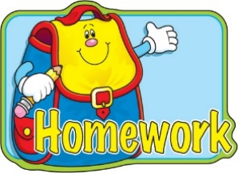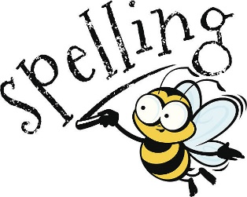When the children are given homework, it will usually be on a Friday which then needs to be returned the following Monday. Homework will help and support to consolidate your child’s learning. Along with homework, the children will need to complete tasks in their **Maths CGP books.** A note will be added on Class Dojo to inform you which pages your child needs to be complete. **Please ensure that these are brought back on a Monday as we will mark them on Monday’s so that more maths homework can be set for the following week.**

Spellings for this half-term were given before the Christmas holidays. Spelling scores will be shared with you via Class Dojo.

All homework, letters, spellings, Knowledge Organisers and relevant information linked to your child’s time in Year 2 can be found on our class page of the school website under the following tabs:

Curriculum/Class Pages/Class 2

The following link will also take you there:

<https://www.holycrossschoolhucknall.com/curriculum/class-pages/class-page-2-2-3/>



**Diary Dates**

**Children’s Rights week –** starting Wednesday 4th January 2023 – the children learn about Children’s Rights.

**Class Mass –** Friday 27th January 2023 at 9:30am. All are welcome. An event will be added to Class Dojo.

**Parents’ Meetings –** Monday 6th February 2023 is for online meetings.

Wednesday 8th February 2023 is for face-to-face meetings.

Information about how to book will be sent nearer the time. Thank you.

**Inset Days –** Friday 10th February 2023

**February half –term –** 1 week – break up on Thursday 9th February 2023 return to school on Monday 20th February 2023.

**Our Farming Assembly –** Tuesday 28th February 2023 at 2:40pm.

All parents/carers are welcome to attend. An event will be added to Class Dojo.

**Visit to Hucknall Library – I will be organising a trip to Hucknall Library with Mr Hammond this term.** I will send out a separate letter once we have organised this to ask for volunteers to help walk us to the library. Thank you.

**World Book Day –** Thursday 2nd March 2023 – more details to follow nearer the time.

**Trip to Pizza Express –** Wednesday 3rd May 2023, am only. Letters and information to be sent nearer the time. Adult volunteers will be needed for this trip. Thank you in advance.

**King Charles III Coronation Day –** Friday 5th May 2023 – all day – More details to follow in a separate letter nearer the time.

Any other diary dates will be given via Class Dojo/letters.

If you have any questions or concerns about anything at all, please do not hesitate to contact me, my door is always open. After school is the best time as mornings can be very busy.

Please ensure that you keep up to date with homework, spellings, news, events, and dates for your diary by checking Class Dojo and our class page on the school website regularly. Thank you.

Thank you in advance for your help and support, as always,

**Miss Duong**