[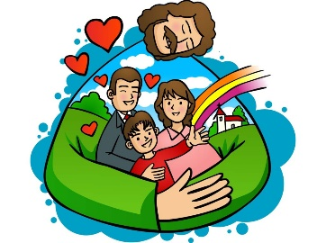](https://www.google.co.uk/url?sa=i&rct=j&q=&esrc=s&source=images&cd=&cad=rja&uact=8&ved=0ahUKEwjvxp_yicrVAhXlCMAKHbIvDn8QjRwIBw&url=https%3A%2F%2F101clipart.com%2Fchristian-family-clipart%2F&psig=AFQjCNH9OiJWNhUlmofSbOZT1NEKfeylUw&ust=1502365485491314)****

**Welcome to the Advent Term**

**Welcome to Class 2 Year 2!**

I hope you all had a fantastic summer and a really good and restful break. I am really looking forward to the new school year and getting to know you all.

**All Newsletters and letters will be added to the new school website under the following tabs: Curriculum/Class Pages/Class 2/Newsletters**

**You can also click on the link below to take you straight to the Advent newsletter:**

[**https://www.holycrossschoolhucknall.com/curriculum/class-pages/class-page-2-2-3/#1644578389373-226a4ede-6c15**](https://www.holycrossschoolhucknall.com/curriculum/class-pages/class-page-2-2-3/#1644578389373-226a4ede-6c15)

Please ensure that you find some time to navigate yourself around the new school website so you can familiarise yourself with it.

**Please see the outline for each subject for the Advent Term.**

**We will also make cross-curricular links to other areas of learning such as art, D&T, PE and ensure that we have a knowledge-rich and ambitious curriculum which teaches the children the depth and breadth of a topic to embed their skills and knowledge in their learning.**



Our **Come and See** topics this term are ‘Beginnings’, ‘Signs and Symbols’ and ‘Preparations’. We shall also be spending a week finding out about another faith. This term we shall be finding out about Judaism and learning about Shabbat.

In ‘Beginnings’, we shall be learning about what the title means, the story of Creation, Genesis I, and how God is with us at our every beginning, what He did, retelling the Creation Story, how and talking about how God in the beginning and what we wonder about. In our ‘Signs and Symbols’ topic, our work will include learning about the signs and symbols all around us, including in our homes and families. We shall be learning about baptism and the signs and symbols involved in this sacrament and some of the actions and phrases the Priest may use. In ‘Preparations’, we shall be looking at how we prepare for special times, the symbols of Advent and the preparations during Advent leading up to Christmastime. This will include our Nativity and how Mary prepared for the birth of baby Jesus.

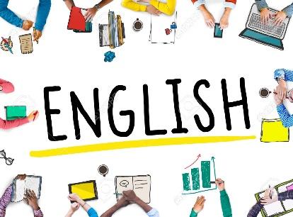

In **English** we shall be reading and linking our writing to our history topic of The Great Fire of London and focus on stories by Jill Murphy; Peace at Last, On the Way Home, Whatever next! and Dear Hound. This term, we will learn to recognise the features of recounts; a diary entry and an autobiographical recount. We will also be reading number of stories by the same author, learning how to recognise and write narratives along with letter writing. We will also look at fiction and non-fiction texts and identifying features of these.

We will also focus on our writing by ensuring that all sentences are punctuated accordingly and learn to join our letters cursively. We shall also be looking at how to improve our writing by using adjectives, a wide range of punctuation, and begin using our editing and redrafting skills. We will also learn to write in different styles; letters, information, poetry, story and focus on ways to make our writing interesting.

We will also have daily phonics and handwriting sessions, ensuring that the children are starting letters with a lead to support them when joining their letters and writing cursively. Our daily phonics sessions will include different ways of spelling the same sound, along with how words should be spelt rather than phonetically and SPAG, Spelling, Punctuation and Grammar, focusing on the fundamentals and basics of writing and language. I will be sending Common Exception Words (CEW) home in the form of flashcards which will support them with their weekly spellings and phonics sessions.

We shall be using our reading **VIPERS** – **V**ocabulary **I**nfer **P**redict **E**xplain **R**etrieve **S**equence - to analyse, improve and support our understanding when reading specific texts in detail.

The children will be exposed to daily reading from the teacher during story and read as a whole class. They will also be reading 1:1, at least once a week to a grown-up too. I will be sending reading books home (coloured book band books) and assigning books on Rising Stars too.

**As part of your child’s weekly homework, please ensure that your child spends at least 10 minutes reading to you each day, and that your child brings their reading books, orange reading diary and book bags, to school every day.**

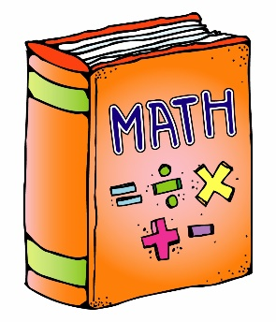

In **Maths** we shall follow the New National Curriculum via our White Rose programme of study, but will have lots of fun putting our learning into the context of our topic. Children will be set weekly maths challenges which will be completed in school on a Friday morning which are vital to support their development of speed and fluency in all aspects of math. This is called the Friday Maths Challenge (FMC) and the children are already familiar with this from Year 1. This will also support their knowledge and understanding and ensure that what they have learnt has been embedded in their long-term memory. We will learn number facts which need to be learnt by heart (for example, all the pairs of numbers that total 5,10 and 20, the 2, 5, 10 and 3-times table) and the inverse (opposite calculations to check your answers) too. The inverse of addition is subtraction and vice versa and the inverse of multiplication is division, to check 3 + 8 = 11 you could do 11 – 8 = 3. It is extremely important that you support your child with these math concepts at home as these facts will underpin much of the maths this year which they will find much easier to access if they know these facts by heart and quickly, but also if they know how to apply these skills concretely (using objects), pictorially (drawing and writing) and abstractly (off by heart and know how and why you came to the answer). This in turn will then support them with their reasoning and problem-solving skills.

[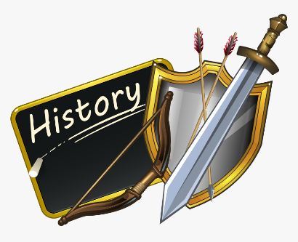](https://www.google.co.uk/url?sa=i&url=https://www.pngitem.com/middle/hJwJbxo_28-collection-of-history-clipart-png-history-clipart/&psig=AOvVaw1vxTiB-qgFn3gqQUFcxth1&ust=1599463153142000&source=images&cd=vfe&ved=0CAIQjRxqFwoTCJiuqeD-0-sCFQAAAAAdAAAAABAD)

In **History**, we shall be learning about the life of another significant individual from the past and events beyond living memory, looking at who Samuel Pepys and Sir Christopher Wren were, what they did and why they are well-known individuals. We will be focusing on the book titled The Great Fire of London in English and learn why they were important figure in history. We will also look at how The Great Fire of London changed London, the impact of the fire, and how it was different after the fire. We will also have lots of discussions and question and answer sessions in our History lessons.

[](https://www.google.co.uk/url?sa=i&url=https://www.netclipart.com/isee/hJbTox_geography-png-free-download-earth-clipart-uk/&psig=AOvVaw1L1SVW9FcyNkVu4ebuB2Om&ust=1599463722966000&source=images&cd=vfe&ved=0CAIQjRxqFwoTCJjVgI2B1OsCFQAAAAAdAAAAABAJ)

In **Geography**, we shall be looking at water and children’s rights to water and sharpening up our geography skills, and then using our geographical skills to compare Hucknall to Uganda. We will recap on previous learning and location knowledge of the continents, seas and poles on an atlas. We shall also be learning how to use our map and compass skills to locate different countries and oceans, and look at the human and physical features of Hucknall and Uganda and think about the following enquiry question; is everywhere like Hucknall?

Our trip to Carsington Water this term will help to embed some of our learning this term. I will confirm the date once it has been booked.

[](https://www.google.co.uk/url?sa=i&url=https://www.netclipart.com/isee/TTJmJ_creative-clipart-painting-party-art-and-craft-logo/&psig=AOvVaw2V8f9P7sI1FjfS-rls7xrg&ust=1599464422460000&source=images&cd=vfe&ved=0CAIQjRxqFwoTCLiFhruD1OsCFQAAAAAdAAAAABAD)In **Design & Technology** the children will be using their designing, creating and evaluating skills. They will design a purposeful, functional and appealing product for themselves, and others based on the design criteria, make the product by selecting from a range of tools and evaluating their final product with their design criteria. The children will explore and use mechanisms; wheels and axels, which we will link to our topic of The Great Fire of London.

In **Art** we shall be looking at and learning all about the French artist Henri Matisse and how to create a collage of The Great Fire of London in the style of Matisse. We will also be looking at his artwork and the techniques he used to create his artwork, critiquing his work along the way.

Our **Science** is broken into three key areas; physics, chemistry and biology. In **Chemistry,** we shall be learning about the uses of everyday materials; wood, plastic, metal, glass, brick, paper and cardboard. We will compare the suitability of everyday materials for different purposes. We will explore how objects made of some everyday materials can change shape and how the recycling process is able to reuse some everyday materials numerous times. Some of the work we do in Science will link to God’s world and making sure we look after it by using less and recycling. We will learn about new discoveries which have been made over time and find out about scientists such as John McAdam, John Macintosh and what they invented.

**[](https://www.google.co.uk/url?sa=i&url=https://www.clipartkey.com/view/iRhixww_healthy-lifestyle-png/&psig=AOvVaw1eXu_Q7F-0_HoerR_IEo-i&ust=1599464881518000&source=images&cd=vfe&ved=0CAIQjRxqFwoTCNju4pyF1OsCFQAAAAAdAAAAABA3)Keeping Healthy**

Please ensure that if your child is having a packed lunch, that they include healthy snacks such as fruit or dried fruit, rather than sweet treats such as chocolate and crisps every day.

In **PE** we shall be learning lots of new strategies to help us in our games. We will be learning the key fundamental skills to help us when we need these skills to play ball/racket games such as hand-eye co-ordination; throwing and catching, team work, target practice and lots more. We will also learn to use how to move to music and use apparatus adequately and safely during our gymnastics and dance lesson this term.

**Note: Please ensure that you do not wear earrings on PE days.**

**Our PE days will be every Monday.**

**Please could children come to school on their PE days in their PE kits. Please ensure that they are wearing no tracksuits with logos but plain navy jumpers and joggers, or their school jumper/cardigan is also fine and a plain white t-shirt. Thank you.**

[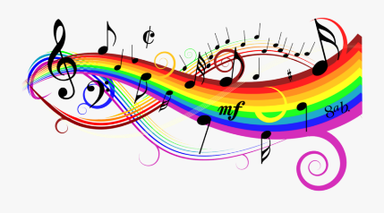](https://www.google.co.uk/url?sa=i&url=https://www.clipartkey.com/view/hJTbwm_freetoedit-rainbow-colorful-music-notes-background-clip-art/&psig=AOvVaw0qQoPPFtrP_ROxZbTNnvYM&ust=1599465610430000&source=images&cd=vfe&ved=0CAIQjRxqFwoTCPj8s-2H1OsCFQAAAAAdAAAAABAI)

We will be following our Charanga scheme of music, learning about pitch, tone, tempo, beat using our voices and musical instruments too. We will also be listening to lots of different songs and thinking about the tone, beat and rhythm, along with how they express how we feel.

We will also take part in some of our Charanga modules and learn some of the songs; Hands, Feet, Heart, Ho Ho Ho, I wanna play in a band, Zootime and Friendship song.

We will also be taking part in addition singing lessons with Mr Davis on a weekly basis, some of which will be shared with parents/carers in December at a Carol Concert at Nottingham Cathedral, see date in the diary dates section below.

[](https://www.google.co.uk/url?sa=i&url=https://www.netclipart.com/isee/boxibJ_ict-teacher-clipart-collection-ict-images-clip-art/&psig=AOvVaw1MtAyOWj_RsaW7JCcIsdx-&ust=1599466539092000&source=images&cd=vfe&ved=0CAIQjRxqFwoTCIiKzqiL1OsCFQAAAAAdAAAAABAD)

In **Computing**, we shall be putting our ICT skills into practice in all our subjects as well as following the Year 2 curriculum for computing skills. We shall be following some of the modules from NCCE – National Centre for Computing Excellence; creating media – digital photography. This will include looking at framing, lighting and the subject when using technology to take photos. We shall also be learning how to keep safe and stay safe when using technology. We will also be using ICT to make music, which will link to some of our music lessons; how music makes us feel, rhythm and patterns, looking at how music can be used, notes and tempo, creating digital music using Chrome Music lab and then reviewing our learning.

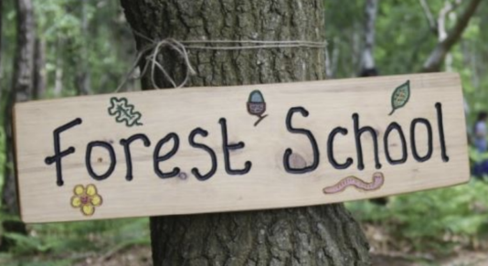**Forest Schools** will be taught by Mrs Hudson on a Wednesday afternoon on alternate weeks.

Please make a note of our Forest Schools sessions for this term in your diary:  
Wednesday 14th September 2022

Wednesday 28th September 2022

Wednesday 12th October 2022

Wednesday 9th November 2022

Wednesday 23rd November 2022

Wednesday 7th December 2022

Wednesday 21st December 2022 – Mrs Hudson and I will update you all at later date as today is the last day of term before we break up for the Christmas holidays. I will update you via Class Dojo nearer the time.

Remember to wear your PE kits and suitable clothing for being outside.

**Plimsolls -** Please bring a pair of plimsolls to change into when you come back into the classroom. These can be kept in school once the building work progresses, and we have more adequate space, so the children always have access to these. Again, I will update you nearer the time.

**Curriculum Letters**

As we are trying to save paper and help the environment by reducing waste, our Curriculum Letter Newsletter, which will give you an insight to all of the topics we will cover this term, will **no longer** be printed for you unless you send me a message via Class Dojo to request a paper copy. They will then be added at the beginning of each term electronically on our class page on the school website; Lent (Spring) and Pentecost (Summer) letters, under the following tab:

**Curriculum tab/ClassPages/Class2/ Newsletters.**

I will also add any trip letters here too. Please access letters and newsletters by clicking on the link below:

[**https://www.holycrossschoolhucknall.com/curriculum/class-pages/class-page-2-2-3/#1644578389373-226a4ede-6c15**](https://www.holycrossschoolhucknall.com/curriculum/class-pages/class-page-2-2-3/#1644578389373-226a4ede-6c15)

**Our School Website**

Please check out our school website regularly to keep up to date with news and events on the following link

<https://www.holycrossschoolhucknall.com/>****

I will also be using Class Dojo to communicate with all parents. If you have any questions or queries, please send me a message via Class Dojo. This allows you to contact me directly rather than emailing/contacting the office/head teacher. I will try to respond as quickly as possible to any messages that I receive.

On occasions, I may set some homework tasks which will need to be completed via your child’s Portfolio to dos on class dojo. I will provide further information of how to do this when I have set a task.

**Labels**

Please ensure you write your child’s name on all their items of clothing as I’m sure you understand all look

the same. I have a permanent marker if you would like to borrow this.

[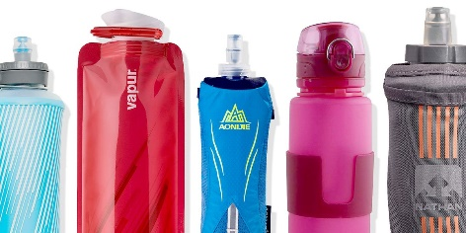](https://www.google.co.uk/url?sa=i&url=https://www.runnersworld.com/gear/a26414940/collapsible-water-bottles/&psig=AOvVaw14JbeRAlzWVzsuRWhwZvVG&ust=1599467232411000&source=images&cd=vfe&ved=0CAIQjRxqFwoTCODny_KN1OsCFQAAAAAdAAAAABAS)

**Water bottles**

Please could you ensure that your child has a water bottle in school at all times with their names clearly labelled on it. Water bottles will be sent home every night to be returned the next day. Please ensure that water bottles are filled with water when they are returned, and I will ensure that the children know how to fill these in class once it becomes empty.

**Fruit**

The Government provides each child with a piece of fresh fruit each day. We receive a variety of fruit; apples, bananas, carrots, strawberries, sugar snap peas, peppers, pears, raisins and lots more. We are a healthy school and would like to promote healthy eating. This will be the last year that the children will receive free fruit and Universal School dinners.

[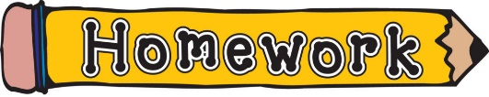](https://www.google.co.uk/url?sa=i&url=https://woodboroughschool.org/classes-curriculum/curriculum-information/homework-clip-art-for-kids-free-clipart-images-3-1024x204/&psig=AOvVaw0KAdxexB0z4NUOJwNw_a7t&ust=1599492400015000&source=images&cd=vfe&ved=0CAIQjRxqFwoTCIDJs9Pr1OsCFQAAAAAdAAAAABAD)

**All homework and spellings will be added to the homework or spellings tab on the class page on the school website in Class 2s tab.**

The children will be given a few types of homework this year. Please see the list of **weekly** homework tasks:

1. **Read at least 4 times a week**, at least 10 minutes each time, write a note in their orange diary of how they read and signed by the grown-up they have read to.

**Reading -** The children will be given reading books and an orange reading diary which needs to be kept in their book bags and brought to school each day.

Please read with your child at least 4 times a week and we will read once individually in school. If your child reads 5 times a week, they will receive a stamp on the charter on the inside cover of their reading diary. One stamp equals 5 reads and for every 25 reads, they will receive a certificate.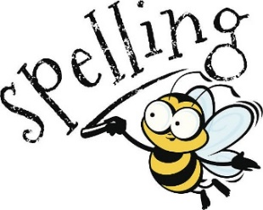

1. **Learn your weekly spellings** ready for spelling test on Friday. I will send Common Exception Words – CEW – flashcards home for the children to cut up and use throughout the year to support with the majority of their weekly spellings. All of the words that have been sent home are words which the children should be able to read, spell/write and apply correctly to their writing by the end of Year 2.

Spellings will be handed out at the beginning of a half-term which will outline the spellings for each week for that half-term. You will notice that as you move down the spellings grid, words will be repeated. These will be tested in a spelling book which will be kept in school and the scores will be shared with you via an email on Class Dojo. Spellings will be added to the class page on the school website, and a paper copy given to your child, at the beginning of each half-term under the Spellings tab.

1. **Log onto Spelling Shed** to play the games that I have assigned. These may link to our phonics learning or retrieval practice from Year 1. I will start to assign games from Monday 12th September 2022.
2. **Come and See Explore Homework** - **once a month** - I will send a piece of paper with our Come and See homework to mark our new topic. Come and See is our Religious Education Programme of study. This will be sent on a Friday to be returned the following Monday.

Please ensure that your child writes their name on the back of their work.

1. **Times Table Rock Stars** – please log on and practise your times tables. This is a fun way to learn your math facts.
2. **Knowledge Organisers** – **KOs –** these will be added to the class page on the school website under the Knowledge Organisers tab at the beginning of each half-term. It will consist of an A4 sheet of paper of information, words or facts about a topic we are learning this term/half-term which will form part of your weekly homework.

Knowledge Organisers include basic knowledge of a topic that we would like your child to learn and embed in their long-term memory to enable them to use the skills/vocabulary in lessons and out of school. We will be using these knowledge organisers in lessons to help us learn about certain topics.

Each week, I will specific which section of the knowledge organiser to learn via a note of Class Dojo.

1. **Portfolio to dos on Class Dojo** – **Every now and then**, some tasks will be set on your child’s Portfolio and I will request how I would like the response type, e.g. photo or video.

It might seem like I have set a lot of homework tasks but some types of homework will be **weekly** tasks that are on-going such as completing Spelling Shed games, Times Table Rock Stars, reading, reading on Rising Stars and learning spellings every week and some, only once a month.

[](https://www.google.co.uk/url?sa=i&url=https://bp.starmat.uk/latest-news/dates-for-your-diary&psig=AOvVaw0yUc3EMgJSzH4vfGl-Il4k&ust=1599493968028000&source=images&cd=vfe&ved=0CAIQjRxqFwoTCKD7g8Hx1OsCFQAAAAAdAAAAABAD)

**Diary Dates –** A few dates for your diary 😊

**E.M.U.S – Education Making Us Safe –** Approximately a 10 week

programme with Mrs Butkevicius starting on Tuesday 13th September 2022. It is designed to equip young children with the knowledge and skills to make good choices and keep safe in a number of different situations

**Meet the Teacher –** Wednesday 7th September 2022 3:30pm. This is an opportunity to pop in and spend 5 or 10minutes having a quick chat with me if you need to.

**Year 2 Maths Parents Workshop** – Monday 19th September 2022 - 9am – 10am – This is a workshop for Parents/Carers to come into school and understand how we teach the children Maths in school. It will be an interactive session where I will teach some concepts and then allow you to practise with your child.

**Macmillan Coffee Afternoon** – Friday 30th September 2022 – 2:30pm.

**Whole School Individual Photos –** Tuesday 4th October 2022.

**Harvest Festival –** Friday 7th October 2022.

**World Mental Health Day – WMHD –** Monday 10th October 2022.

**Termly Learning Meetings for Parents – Face to Face appointments –** Monday 10th October 2022 starting after school.

**Termly Learning Meetings for Parents – online appointments via TEAMs –** Wednesday 12th October 2022 starting after school.

**October half-term -** 2 weeks – break up on Friday 14th October 2022 and back to school on Monday 31st October 2022.

**Trip to Carsington Water –** This will be this term. I will confirm once I have managed to book this.

**Remembrance Day –** Friday 11th November 2022.

**Anti-Bullying Week –** starting on Monday 14th November 2022.

**First day of Advent –** Thursday 1st December 2022.

**Non-Uniform Day –** Friday 2nd December 2022 – bring a chocolate item for the raffle for Christmas Fair.

**Nottingham Cathedral Carol Concert Year 2 & Year 3 –** Tuesday 6th December 2022 – 6pm – 7pm.

**Immunisations –** Wednesday 7th December 2022.

**Christmas Jumper and Dinner Day –** Thursday 8th December 2022.

**Non-Uniform Day –** Friday 9th December 2022 – bring a bottle for the bottle stall - Christmas Fair.

**Year 2 Nativity – Afternoon Performance – Starting at 2:15pm -** Wednesday 14th December 2022.

**Year 2 Nativity – Evening Performance – Starting at 6:15pm -** Wednesday 14th December 2022.

**EYFS and KS1 Christmas Party –** Please come to school dressed in sensible party clothes and shoes.

Letters about specific events/trips will be sent out nearer the time.

If you require any support for your child’s mental health and wellbeing, there is information on our school website which you can access by clicking on the link below. Alternatively, you can come and speak to me, and I support in any way I can.

[**https://www.holycrossschoolhucknall.com/parents/mental-health-and-wellbeing/**](https://www.holycrossschoolhucknall.com/parents/mental-health-and-wellbeing/)

I look forward to working with you to ensure a happy and productive time for the children who are the centre of all we do as we strive to give your child the best possible education as they progress through Holy Cross School.

I look forward to working with you all this year. Thank you in advance for your help and support as always.

**Miss Duong**