

Please find attached all of the spellings for this half-term. As we progress down the pyramid, the same words will keep appearing to support retrieval practice. This is so your child will grow in confidence by being able to recognise and apply the words in their work. Please support your child by using these spellings to practise testing each week. We will begin this week with some familiar words.

**Spellings for Group 3**

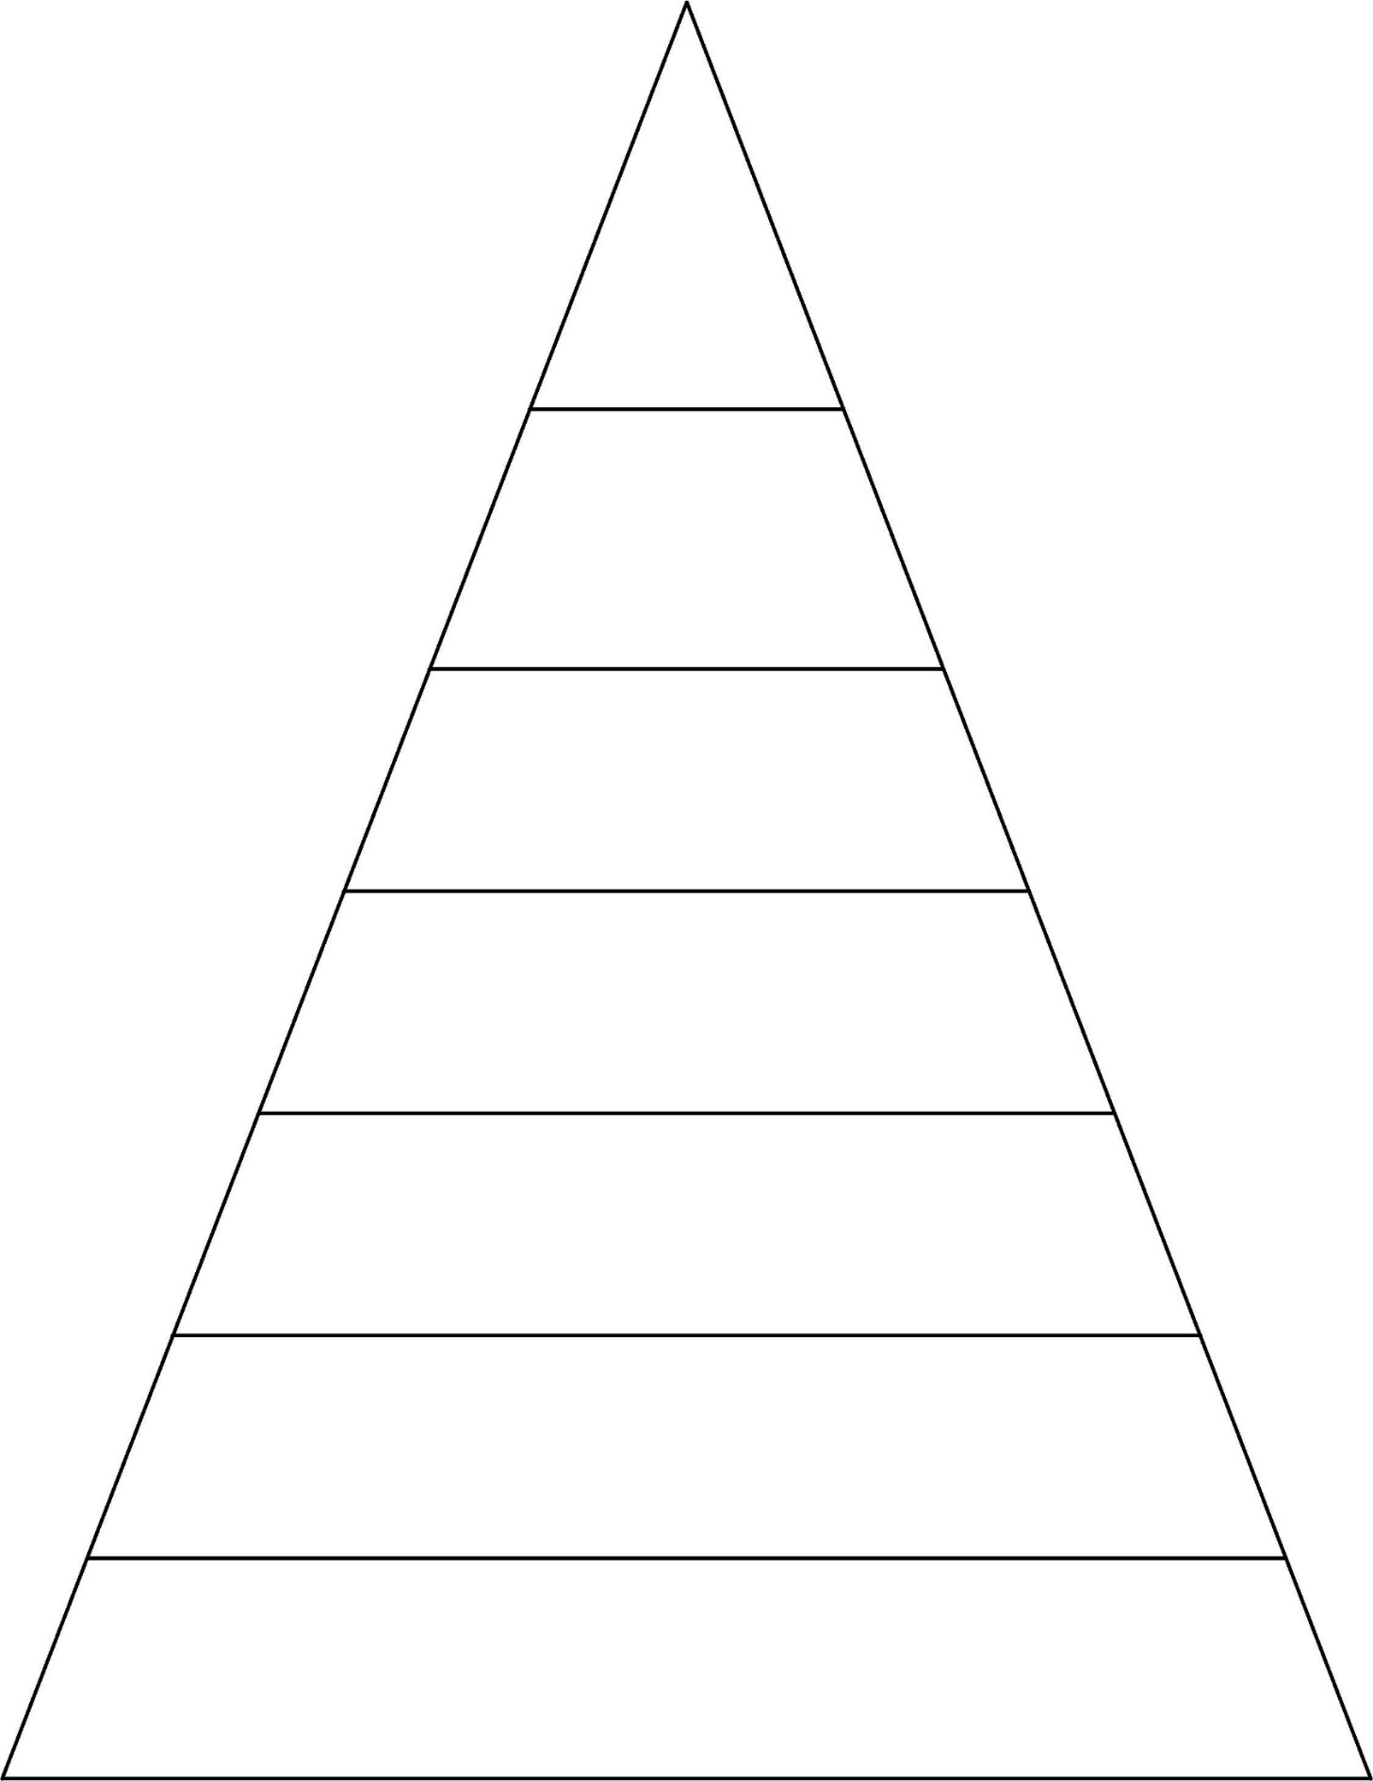

often

decide

appear

although

often decide appear although enough favourite exercise accident

often decide appear although enough favourite exercise accident forgetting forgotten prefer preferred

often decide appear although enough favourite exercise accident forgetting forgotten prefer preferred disappoint disagree misbehave misspell

often decide appear although enough favourite exercise accident forgetting forgotten prefer preferred disappoint disagree misbehave misspell refresh return reappear redecorate

often decide appear although enough favourite exercise accident forgetting forgotten prefer preferred disappoint disagree misbehave misspell refresh return reappear redecorate antiseptic anticlockwise impossible impatient