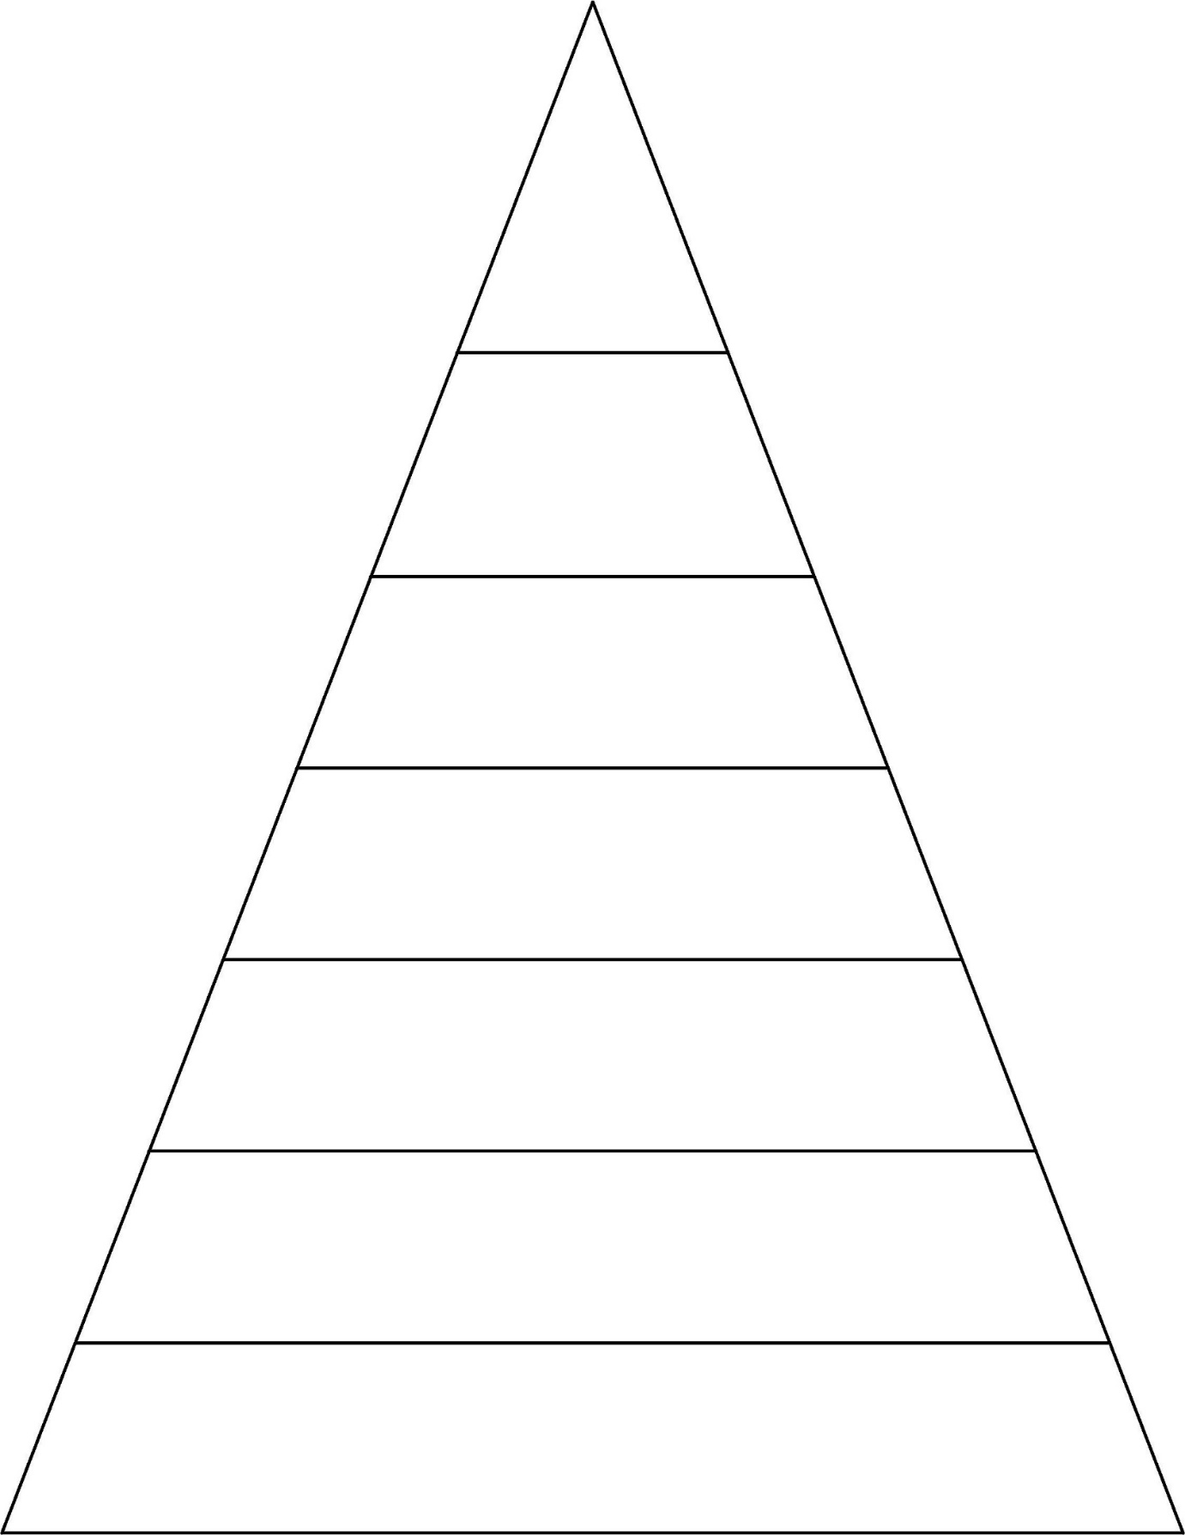

door

floor

poor

because

door floor poor because find mind kind behind

door floor poor because find mind kind behind child most wild climb

door floor poor because find mind kind behind child most wild climb great break pretty beautiful

door floor poor because find mind kind behind child most wild climb great break pretty beautiful hour eye move improve

door floor poor because find mind kind behind child most wild climb great break pretty beautiful hour eye move improve sure sugar could should

Please find attached all of the spellings for this half-term. As we progress down the pyramid, the same words will keep appearing to support retrieval practice. This is so your child will grow in confidence by being able to recognise and apply the words in their work. Please support your child by using these spellings to practise testing each week. We will begin this week with some familiar words. As you will see, most of them are Common Exception Words (CEW).

**Spellings for Group 2**