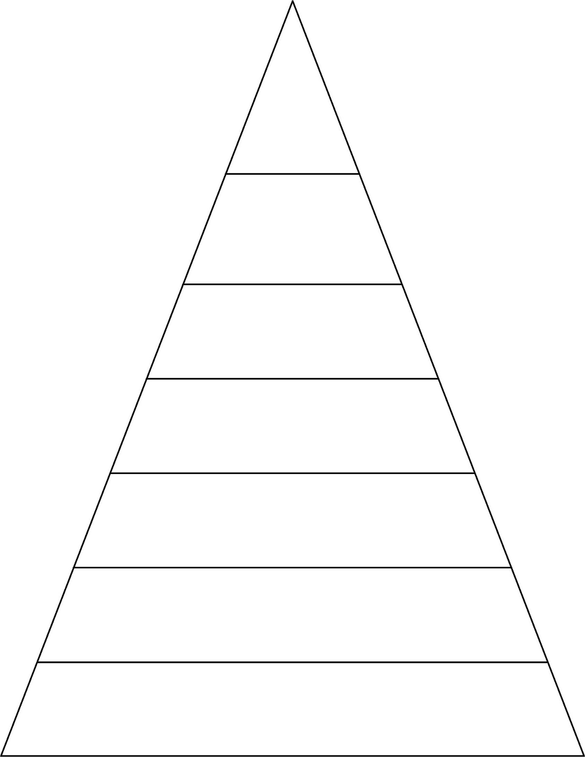

says

come

here

there

says come

here there

book took

foot wood

says come here there

book took foot wood

lie pie tried cried

says come here there book took foot wood lie pie tried cried door floor poor because

says come here there book took foot wood lie pie tried cried door floor poor because find mind kind behind

says come here there book took foot wood lie pie tried cried door floor poor because find mind kind behind happy funny party family

Please find attached all of the spellings for this half-term. As we progress down the pyramid, the same words will keep appearing to support retrieval practice. This is so your child will grow in confidence by being able to recognise and apply the words in their work. Please support your child by using these spellings to practise testing each week. We will begin this week with some familiar words. As you will see, most of them are Common Exception Words (CEW).

**Spellings for Group 1**